Thank you for your purchase! The most recent documentation can be found online. If you have any questions feel free to post on the forums or email [support@opsive.com.](mailto:support@opsive.com)

# Overview

Behavior Designer is a behavior tree implementation designed for everyone - programmers, artists, designers. Behavior Designer offers a powerful API allowing you to easily create new tasks. it offers an intuitive visual editor with PlayMaker and uScript integration which makes it possible to create complex AIs without having to write a single line of code.

This guide is going to give a general overview of all aspects of Behavior Designer. If you don’t know what behavior trees are take a look at our quick overview of behavior trees. With Behavior Designer you don’t need to know how behavior trees are implemented but it is a good idea to know some of the key concepts such as the types of tasks (action, composite, conditional and decorator). You can watch the video version of this topic here.

When you first open Behavior Designer you’ll be presented with the following window:

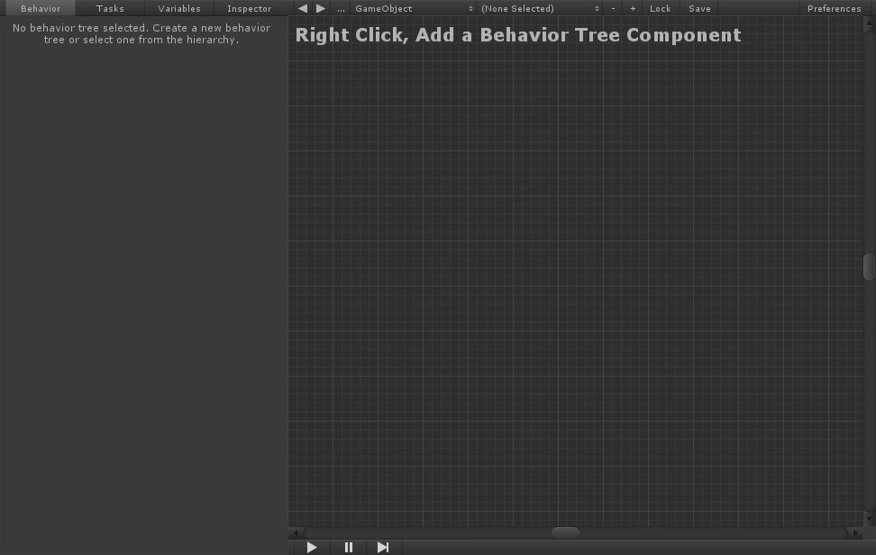

There are four sections within Behavior Designer. From the screenshot below, section 1 is the graph area. It is where you’ll be creating the behavior trees. Section 2 is a properties panel. The properties panel is where you’ll be editing the specific properties of a behavior tree, adding new tasks, creating new variables, or editing the parameters of a task. Section 3 is the behavior tree operations toolbar. You can use the drop down boxes to select existing behavior trees or add/remove behavior trees. The final section, section 4, is the debug toolbar. You can start/stop, step, and pause Unity within this panel. In addition, you'll see the number of errors that your tree has even before you start executing your tree.

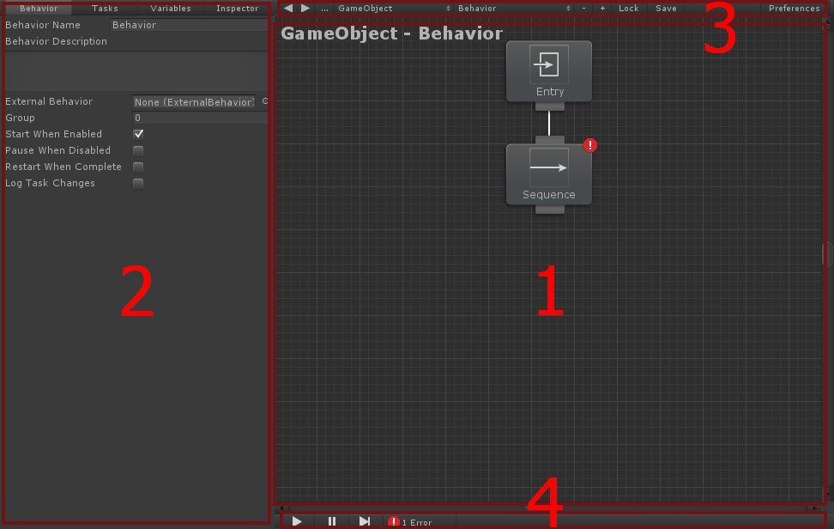

Section 1 is the main part of Behavior Designer that you’ll be working in. Within this section you can create new tasks and arrange those tasks into a behavior tree. To start things off, you first need to add a Behavior Tree component. The Behavior Tree component will act as the manager of the behavior tree that you are just starting to create. You can create a new Behavior Tree component by right clicking within the graph area and clicking “Add Behavior Tree” or by clicking on the plus button next to “Lock” within the operations area of section 3.

Once a Behavior Tree has been added you can start adding tasks. Add a task by right clicking within the graph area or clicking on the “Tasks” tab within section 2, the properties panel. Once a task has been added you’ll see the following:

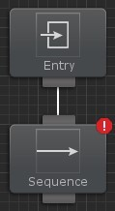

In addition to the task that you added, the entry task also gets added. The entry task acts as the root of the tree. That is the only purpose of the entry task. The sequence task has an error because it has no children. As soon as you add a child the error will go away. Now that we’ve added our first task lets add a few more:

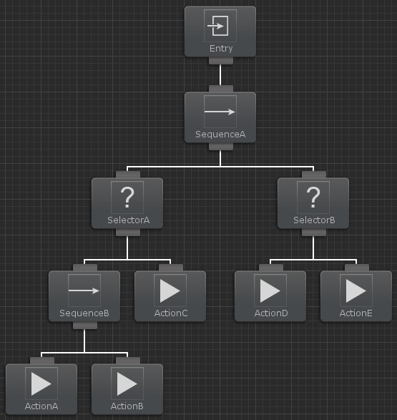

You can connect the sequence and selector task by dragging from the bottom of the sequence task to the top of the selector task. Repeat this process for the rest of the tasks. If you make a mistake you can selection a connection and delete it with the delete key. You can also rearrange the tasks by clicking on a task and dragging it around.

Behavior Designer will execute the tasks in a depth first order. You can change the execution order of the tasks by dragging them to the left/right of their sibling. From the screenshot above, the tasks will be executed in the following order:

SequenceA, SelectorA, SequenceB, ActionA, ActionB, ActionC, SelectorB, ActionD, ActionE

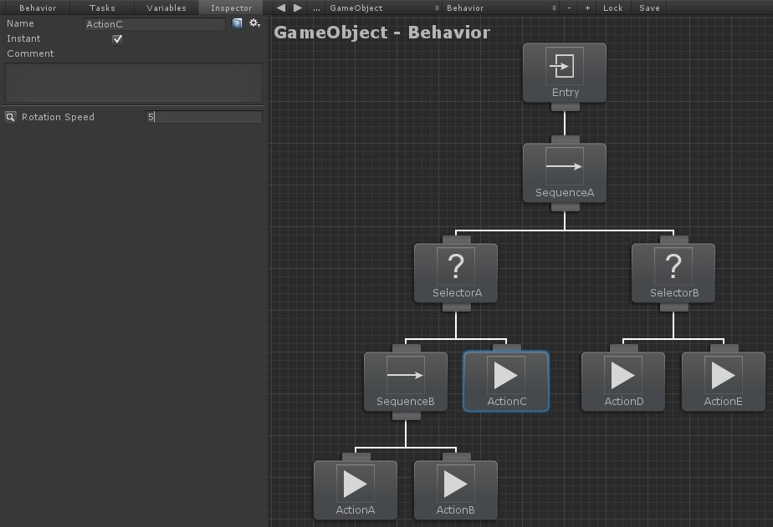

Now that we have a basic behavior tree created, lets modify the parameters on one of the tasks. Select the ActionC node to bring up the Inspector within the properties panel. You can see here that we can rename the task, set the task to be instant, or enter a task comment. In addition, we can modify all public variables the task class contains. This includes assigning variables created within Behavior Designer. In our case the only public variable is the “Rotation Speed”. The value that we set the parameter to will be used within the behavior tree.

There are three other tabs within the properties panel: Variables, Tasks, and Behavior. The variables panel allows you to create variables that are shared between tasks. For more information take a look at the variables topic. The tasks panel lists all of the possible tasks that you can use. This is the same list as what is found when you right click and add a task. This list is created by searching for any class that is derived from the action, composite, conditional, or decorator task type. The last panel, the behavior panel, shows the inspector for the Behavior Tree component that you added when you first created a behavior tree. More details on what each option does can be found here.



The final section within the Behavior Designer window is the operations toolbar. The operations toolbar is mostly used for selecting behavior trees as well as adding/removing behavior trees. The arrows with the number 1 label will navigate between the behavior trees that you have opened. The drop down box with the number 2 label will list all of the behavior trees that are within the scene or the project. This means that it will include prefabs. The drop down box with the number 3 label will list any game object that has a behavior tree component added to it. This is also within the scene or project. Finally, the drop down box with the number 4 label will list any behavior trees that are attached to the game object that is selected from the number 3 drop down box.

The button with the number 5 label will remove the currently selected behavior tree. The button with the number 6 label will add a new behavior tree. The “Lock” button (number 7) will keep the active behavior tree selected even if you select a different game object within the hierarchy or project window. The “Save” button (number 8) will save the current behavior tree out as an asset. Finally, the “Preferences” button (number 9) will show any Behavior Designer preferences.

# What is a Behavior Tree?

Behavior trees are a popular AI technique used in many games. Halo 2 was the first mainstream game to use behavior trees and they started to become more popular after a detailed description of how they were used in Halo 2 was released. Behavior trees are a combination of many different AI techniques: hierarchical state machines, scheduling, planning, and action execution. One of their main advantages is that they are easy to understand and can be created using a visual editor.

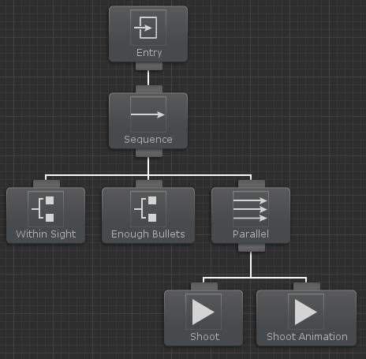

At the simplest level behavior trees are a collection of tasks. There are four different types of tasks: action, conditional, composite, and decorator. Action tasks are probably the easiest to understand in that they alter the state of the game in some way. Conditional tasks test some property of the game. For example, in the tree above the AI agent has two conditional tasks and two action tasks. The first two conditional tasks check to see if there is an enemy within sight of the agent and then ensures the agent has enough bullets to fire his weapon. If both of these conditions are true then the two action tasks will run. One of the action tasks shoots the weapon and the other task plays a shooting animation. The real power of behavior trees comes into play when you form different sub-trees. The two shooting actions could form one sub-tree. If one of the earlier conditional tasks fails then another sub-tree could be made that plays a different set of action tasks such as running away from the enemy. You can group sub-trees on top of each other to form a high level behavior.

Composite tasks are a parent task that hold a list of child tasks. From the above example, the composite tasks are labeled sequence and parallel. A sequence task runs each task once until all tasks have been run. It first runs the conditional task that checks to see if an enemy is within sight. If an enemy is within sight then it will run the conditional task that checks to see if the agent has any bullets left. If the agent has enough bullets then the parallel task will run that shoots the weapon and plays the shooting animation. Where a sequence task executes one child task at a time, a parallel task executes all of its children at the same time.

The final type of task is the decorator task. The decorator task is a parent task that can only have one child. Its function is to modify the behavior of the child task in some way. In the above example we didn’t use a decorator task but you may want to use one if you want to stop a task from running prematurely (called the interrupt task). For example, an agent could be performing a task such as collecting resources. It could then have an interrupt task that will stop the collection of resources if an enemy is nearby. Another example of a decorator task is one that reruns its child task x number of times or a decorator task that keeps running the child task until it completes successfully.

One of the major behavior tree topics that we have left out so far is the return status of a task. You may have a task that takes more than one frame to complete. For example, most animations aren't going to start and finish within just one frame. In addition, conditional tasks need a way to tell their parent task whether or not the condition was true so the parent task can decide if it should keep running its children. Both of these problems can be solved using a task status. A task is in one of three different states: running, success, or failure. In the first example the shoot animation task has a task status of running for as long as the shoot animation is playing. The conditional task of determining if an enemy is within sight will return success or failure within one frame.

Behavior Designer takes all of these concepts and packages it up in an easy to use interface with an API that is similar to Unity’s MonoBehaviour API. Behavior Designer

includes many composite and decorator classes within the standard installation. Action and conditional tasks are more game specific so not as many of those tasks are included but there are many examples within the sample projects. New tasks can be created by extending from one of the task types, or they can be created using PlayMaker or uScript. In addition, many videos have been created to make learning Behavior Designer as easy as possible.

# Behavior Trees or Finite State Machines

In what situations do you use a behavior tree over a finite state machine (such as Playmaker)? At the highest level, behavior trees are used for AI while finite state machines (FSMs) are used for more general visual programming. While you can use behavior trees for general visual programming and finite state machines for AI, this is not what each tool was designed to do. According to some, the age of finite state machines is over. We aren't going to go that far, but behavior trees definitely have their advantages over finite state machines when it comes to AI.

Behavior trees have a few advantages over FSMs: they provide lots of flexibility, are very powerful, and they are really easy to make changes to.

Lets first look at the first advantage: flexibility. With a FSM, how do you run two different states at once? The only way is to create two separate FSMs. With a behavior tree all that you need to do is add the parallel task and you are done - all child tasks will be running in parallel. With Behavior Designer, those child tasks could be a PlayMaker FSM and those FSMs will be running in parallel.

One more example of flexibility is the task guard task. In this example you have two different tasks that play a sound effect. The two different tasks are in two different branches of the behavior tree so they do not know about each other and could potentially play the sound effect at the same time. You don't want this to happen because it doesn't sound good. In this situation you can add a semaphore task (called a Task Guard in Behavior Designer) and it will only allow one sound effect to play at a time. When the first sound finishes playing the second one will start playing.

Another advantage of behavior trees are that they are powerful. That isn't to say that FSMs aren't powerful, it is just that they are powerful in different ways. In our view behavior trees allow your AI to react to current game state easier than finite state machines do. It is easier to create a behavior tree that will react to all sorts of situations whereas it would take a lot of states and transitions with a finite state machine in order to have similar AI. In order to achieve the same results with a FSM you would end up with a spaghetti state machine.

One final behavior tree advantage is that they are really easy to make changes to. One of the reasons behavior trees became so popular is because they are easy to create with a visual editor. If you want to change the state execution order with a FSM you have to change the transitions between states. With a behavior tree, all you have to do is drag the task. You don't have to worry about transitions. Also, it is really easy to completely change how the AI reacts to different situations just by changing the tasks around or adding a new parent task to a branch of tasks.

With that said, behavior trees and FSMs don't have to be mutually exclusive. Behavior trees can describe the *flow* of the AI while the FSM describes the *function*. This combination gives you the power of behavior trees while still having the functionality of FSMs.

# Installation

After Behavior Designer is imported you can access it from the Tools toolbar. If you will be writing your tasks in UnityScript you will need to make a minor directory change to enable the UnityScript class to see the C# classes.

You can access the runtime source code by extracting downloading and extracting the Runtime Source Code package located here. Before you extract this package ensure that you have deleted the runtime and editor assemblies otherwise you'll get a compile error.

# Accessing UnityScript/Boo Tasks

Even though all of the Behavior Designer tasks are written in C#, tasks can also be written in UnityScript or Boo. Due to the order that Unity compiles scripts, you'll first need to rearrange the Behavior Designer directory. By default, Behavior Designer installs in the following locations:

/Behavior Designer/Editor/...

/Behavior Designer/Runtime/...

/Behavior Designer/Third Party/...

/Gizmos

The only change that you need to make is to move the Runtime and Third Party directories to a folder that gets compiled first, such as Plugins. You will then have the following directory structure:

/Behavior Designer/Editor/...

/Gizmos

/Plugins/Behavior Designer/Runtime/...

/Plugins/Behavior Designer/Third Party/...

You will then be able to inherit your UnityScript/Boo object from a Task subclass, just as you would in C#. For example, the following UnityScript task is inherited from Action:

#pragma strict

class UnityScriptAction extends BehaviorDesigner.Runtime.Tasks.Action

{

...

}

If you have extracted the runtime source code you will need to make a similar change.

# Compiling for the Windows Store/Phone

In order to compile Behavior Designer for the Windows Store and Windows Phone you must use the runtime source code instead of the compiled DLL. For instructions on how to extract the runtime source code take a look at the bottom of the installation topic. No compile settings need to be changed - Behavior Designer can compile with .Net Core enabled.

# Behavior Tree Component

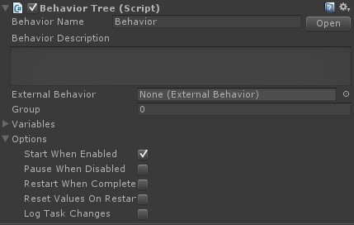

The behavior tree component stores your behavior tree and acts as the interface between Behavior Designer and the tasks. The following API is exposed for starting and stopping your behavior tree:

public void EnableBehavior();

public void DisableBehavior(bool pause = false);

You can find tasks using one of the following methods:

TaskType FindTask< TaskType >();

List< TaskType > FindTasks< TaskType >(); Task FindTaskWithName(string taskName);

List< Task > FindTasksWithName(string taskName);

The current execution status of the tree can be obtained by calling:

behaviorTree.ExecutionStatus;

A status of Running will be returned when the tree is running. When the tree finishes the execution status will be Success or Failure depending on the task results. The following events can also be subscribed to:

OnBehaviorStart OnBehaviorRestart OnBehaviorEnd

The behavior tree component has the following properties:

*Behavior Name*

The name of the behavior tree

*Behavior Description*

Describes what the behavior tree does

*External Behavior*

A field to specify the external behavior tree that should be run when this behavior tree starts

*Group*

A numerical grouping of behavior trees. Can be used to easily find behavior trees. The CTF sample project shows an example of this

*Start When Enabled*

If true, the behavior tree will start running when the component is enabled

*Pause When Disabled*

If true, the behavior tree will pause when the component is disabled. If false, the behavior tree will end

*Restart When Complete*

If true, the behavior tree will restart from the beginning when it has completed execution. If false, the behavior tree will end

*Reset Values On Restart*

If true, the variables and task public variables will be reset to their original values when the tree restarts

*Log Task Changes*

Used for debugging. If enabled, the behavior tree will output any time a task status changes, such as it starting or stopping

# Creating a Behavior Tree from Script

In some circumstances you might want to create a behavior tree from script instead of directly relying on a prefab to contain the behavior tree for you. For example, you may have saved out an external behavior tree and want to load that tree in from a newly created behavior tree. This is possible by setting the externalBehavior variable on the behavior tree component:

using UnityEngine;

using BehaviorDesigner.Runtime;

public class CreateTree : MonoBehaviour

{

public ExternalBehaviorTree behaviorTree;

void Start () {

var bt = gameObject.AddComponent(); bt.ExternalBehavior = behaviorTree; bt.StartWhenEnabled = false;

}

}

In this example the public variable behaviorTree contains a reference to your external behavior tree. When the newly created tree loads it will load the external behavior tree for all of its tasks. To prevent the tree from running immediately we set startWhenEnabled to false. The tree can then be started manually with bt.enableBehavior().

# Behavior Manager

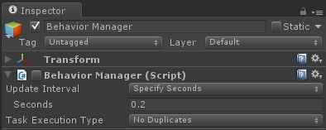

When a behavior tree runs it creates a new GameObject with a BehaviorManager component if it isn't already created. This component manages the execution of all of the behavior trees in your scene.

You can control how often the behavior trees tick by changing the update interval property. "Every Frame" will tick the behavior trees every frame within the Update loop. "Specify Seconds" allows you to tick the behavior trees a given number of seconds. The final option is "Manual" which will give you the control of when to tick the behavior trees. You can tick the behavior trees by calling tick:

BehaviorManager.instance.Tick();

In addition, if you want each behavior tree to have its own tick rate you can tick each behavior tree manually with:

BehaviorManager.instance.Tick(BehaviorTree);

Task Execution Type allows you to specify if the behavior tree should continue executing tasks until it hits an already executed task during that tick or if it should continue to execute the tasks until a maximum number of tasks have been executed during that tick. As an example, consider the following behavior tree:

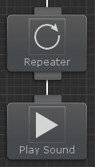

The Repeater task is set to repeat 5 times. If the Task Execute Type is set to No Duplicates, the Play Sound task will only execute once during a single tick. If the Task Execution Type is set to Count, a maximum task execution count can be specified. If a value of 5 is specified then the Play Sound task will execute all 5 times in a single tick.

# Tasks

At the highest level a behavior tree is a collection of tasks. Tasks have a similar API to Unity’s MonoBehaviour so it should be really easy to get started writing your own tasks. The task class has the following API:

// OnAwake is called once when the behavior tree is enabled. Think of it as a constructor public virtual void OnAwake();

// OnStart is called immediately before execution. It is used to setup any variables that need to be reset from the previous run public virtual void OnStart();

// OnUpdate runs the actual task public virtual TaskStatus OnUpdate();

// OnEnd is called after execution on a success or failure. public virtual void OnEnd();

// OnPause is called when the behavior is paused and resumed public virtual void OnPause(bool paused);

// The priority select will need to know this tasks priority of running public virtual float GetPriority();

// OnBehaviorComplete is called after the behavior tree finishes executing public virtual void OnBehaviorComplete();

// OnReset is called by the inspector to reset the public properties public virtual void OnReset();

// Allow OnDrawGizmos to be called from the tasks public virtual void OnDrawGizmos();

// Keep a reference to the behavior that owns this task public Behavior Owner;

Tasks have three exposed properties: name, comment, and instant. Instant is the only property that isn't obvious in what it does. When a task returns success or fail it immediately moves onto the next task within the same update tick. If you uncheck the instant task it will now wait a update tick before the next task gets executed. This is an easy way to throttle the behavior tree.

The following flow chart is used when executing the task:

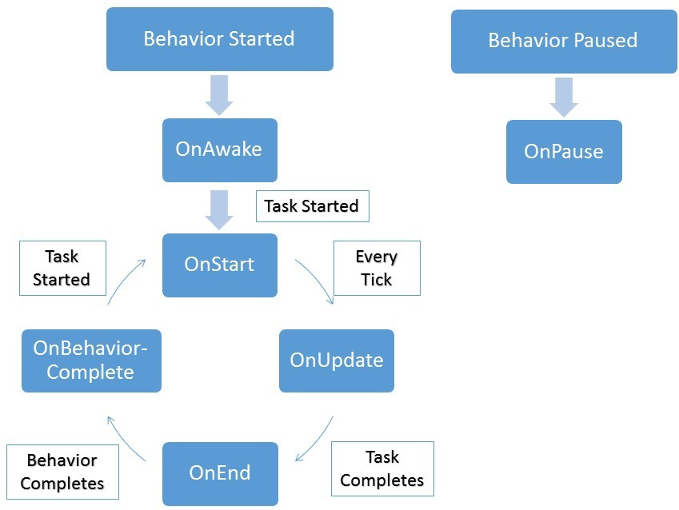

# Parent Tasks

Parent Tasks are the composite and decorator tasks within the behavior tree. While the ParentTask API has no equivalent API to Unity’s MonoBehaviour class, it is still pretty easy to determine what each method is used for.

// The maximum number of children a parent task can have. Will usually be 1 or int.MaxValue public virtual int MaxChildren();

// Boolean value to determine if the current task is a parallel task public virtual bool CanRunParallelChildren();

// The index of the currently active child public virtual int CurrentChildIndex();

// Boolean value to determine if the current task can execute public virtual bool CanExecute();

// Apply a decorator to the executed status

public virtual TaskStatus Decorate(TaskStatus status);

// Notifies the parent task that the child has been executed and has a status of childStatus public virtual void OnChildExecuted(TaskStatus childStatus);

// Notifies the parent task that the child at index childIndex has been executed and has a status of childStatus public virtual void OnChildExecuted(int childIndex, TaskStatus childStatus);

// Notifies the task that the child has started to run public virtual void OnChildStarted();

// Notifies the parallel task that the child at index childIndex has started to run public virtual void OnChildStarted(int childIndex);

// Some parent tasks need to be able to override the status, such as parallel tasks public virtual TaskStatus OverrideStatus(TaskStatus status);

// The interrupt node will override the status if it has been interrupted. public virtual TaskStatus OverrideStatus();

// Notifies the composite task that an conditional abort has been triggered and the child index should reset

public virtual void OnConditionalAbort(int childIndex);

# Writing a New Conditional Task

This topic is divided into two parts. The first part describes writing a new conditional task, and the second part (available here) describes writing a new action task. The conditional task will determine if any objects are within sight and the action class will towards the object that is within sight. We will also be using variables for both of these tasks. We have also recorded a video on this topic and it is available here.

The first task that we will write is the Within Sight task. Since this task will not be changing game state and is just checking the status of the game this task will be derived from the Conditional task. Make sure you have the BehaviorDesigner.Runtime.Tasks namespace included:

using UnityEngine;

using BehaviorDesigner.Runtime.Tasks;

public class WithinSight : Conditional

{

}

We now need to create three public variables and one private variable:

using UnityEngine;

using BehaviorDesigner.Runtime;

using BehaviorDesigner.Runtime.Tasks;

public class WithinSight : Conditional

{

public float fieldOfViewAngle; public string targetTag; public SharedTransform target;

private Transform[] possibleTargets;

}

The fieldOfViewAngle is the field of view that the object can see. targetTag is the tag of the targets that the object can move towards. target is a shared variable which will be used by both the Within Sight and the Move Towards tasks. If you are using shared variables make sure you include the BehaviorDesigner.Runtime namespace. The final variable, possibleTargets, is a cache of all of the Transforms with the targetTag. If you take a look at the task API, you can see that we can create that cache within the the OnAwake or OnStart method. Since the list of possible transforms are not going to be changing as the Within Sight task is enabled/disabled we are going to do the caching within OnAwake:

public override void OnAwake()

{

var targets = GameObject.FindGameObjectsWithTag(targetTag); possibleTargets = new Transform[targets.Length];

for (int i = 0; i < targets.Length; ++i) { possibleTargets[i] = targets[i].transform;

}

}

This OnAwake method will find all of the GameObjects with the targetTag, then loop through them caching their transform in the possibleTargets array. The possibleTargets array is then used by the overridden OnUpdate method:

public override TaskStatus OnUpdate()

{

for (int i = 0; i < possibleTargets.Length; ++i) {

if (withinSight(possibleTargets[i], fieldOfViewAngle)) { target.Value = possibleTargets[i];

return TaskStatus.Success;

}

}

return TaskStatus.Failure;

}

Every time the task is updated it checks to see if any of the possibleTargets are within sight. If one target is within sight it will set the target value and return success. Setting this target value is key as this allows to Move Towards task to know what direction to move in. If there are no targets within sight then the task will return failure. The last part of this task is the withinSight method:

public bool withinSight(Transform targetTransform, float fieldOfViewAngle)

{

Vector3 direction = targetTransform.position - transform.position; return Vector3.Angle(direction, transform.forward) < fieldOfViewAngle;

}

This method first gets a direction vector between the current transform and the target transform. It will then compute the angle between the direction vector and the current forward vector to determine the angle. If that angle is less then fieldOfViewAngle then the target transform is within sight of the current transform. One thing to note is that unlike MonoBehaviour objects, all tasks already have all of the MonoBehaviour components cached so we do not need to precache the transform component.

That's it for the Within Sight task. Here's what the full task looks like:

using UnityEngine;

using BehaviorDesigner.Runtime;

using BehaviorDesigner.Runtime.Tasks;

public class WithinSight : Conditional

{

// How wide of an angle the object can see public float fieldOfViewAngle;

// The tag of the targets public string targetTag;

// Set the target variable when a target has been found so the subsequent tasks know which object is the target

public SharedTransform target;

// A cache of all of the possible targets private Transform[] possibleTargets;

public override void OnAwake()

{

// Cache all of the transforms that have a tag of targetTag var targets = GameObject.FindGameObjectsWithTag(targetTag); possibleTargets = new Transform[targets.Length];

for (int i = 0; i < targets.Length; ++i) { possibleTargets[i] = targets[i].transform;

}

}

public override TaskStatus OnUpdate()

{

// Return success if a target is within sight

for (int i = 0; i < possibleTargets.Length; ++i) {

if (withinSight(possibleTargets[i], fieldOfViewAngle)) {

// Set the target so other tasks will know which transform is within sight target.Value = possibleTargets[i];

return TaskStatus.Success;

}

}

return TaskStatus.Failure;

}

// Returns true if targetTransform is within sight of current transform public bool withinSight(Transform targetTransform, float fieldOfViewAngle)

{

Vector3 direction = targetTransform.position - transform.position;

// An object is within sight if the angle is less than field of view return Vector3.Angle(direction, transform.forward) < fieldOfViewAngle;

}

}

Continue to the second part of this topic, writing the Move Towards task.

# Writing a New Action Task

This topic is a continuation of the previous topic. It is recommended that you first take a look at the writing a new conditional task topic first.

The next task that we are going to write is the Move Towards task. Since this task is going to be changing the game state (moving an object from one position to another), we will derive the task from the Action class:

using UnityEngine;

using BehaviorDesigner.Runtime.Tasks;

public class MoveTowards : Action

{

}

This class will only need two variables: a way to set the speed and the transform of the object that we are targetting:

using UnityEngine;

using BehaviorDesigner.Runtime;

using BehaviorDesigner.Runtime.Tasks;

public class MoveTowards : Action

{

public float speed = 0;

public SharedTransform target;

}

The target variable is a SharedTransform and it will be set from the Within Sight task that will run just before the Move Towards task. To do the actual movement, we will need to override the OnUpdate method:

public override TaskStatus OnUpdate()

{

if (Vector3.SqrMagnitude(transform.position - target.Value.position) < 0.1f) { return TaskStatus.Success;

}

transform.position = Vector3.MoveTowards(transform.position, target.Value.position, speed * Time.deltaTime); return TaskStatus.Running;

}

When the OnUpdate method is run, it will check to see if the object has reached the target. If the object has reached the target then the task will success. If the target has not been reached yet the object will move towards the target at a speed specified by the speed variable. Since the object hasn't reached the target yet the task will return running.

That's the entire Move Towards task. The full task looks like:

using UnityEngine;

using BehaviorDesigner.Runtime;

using BehaviorDesigner.Runtime.Tasks;

public class MoveTowards : Action

{

// The speed of the object public float speed = 0;

// The transform that the object is moving towards public SharedTransform target;

public override TaskStatus OnUpdate()

{

// Return a task status of success once we've reached the target

if (Vector3.SqrMagnitude(transform.position - target.Value.position) < 0.1f) { return TaskStatus.Success;

}

// We haven't reached the target yet so keep moving towards it

transform.position = Vector3.MoveTowards(transform.position, target.Value.position, speed * Time.deltaTime); return TaskStatus.Running;

}

}

Now that these two tasks are written, parent the tasks by a sequence task and set the variables within the task inspector. Make sure you've also created a new variable within Behavior Designer:

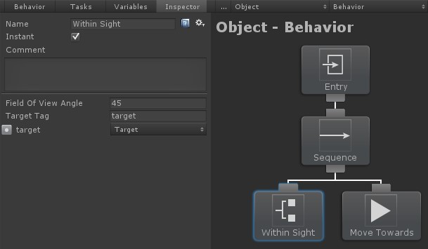

That's it! Create a few moving GameObjects within the scene assigned with the same tag as targetTag. When the game starts the object with the behavior tree attached with move towards whatever object first appears within its field of view. This was a pretty basic example and the tasks can get a lot more complicated depending on what you want them to do. All of the tasks within the sample projects are well commented so you should be able to pick it up from there. In addition, we have written some more documentation on the continuing topics such as variables, referencing tasks and task attributes.

# Debugging

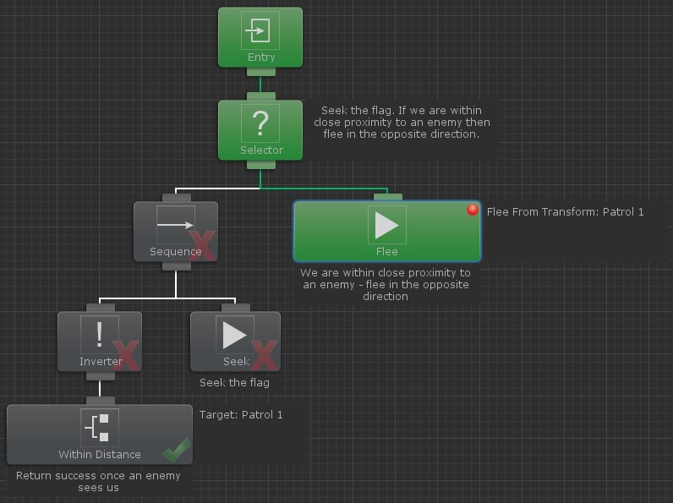

When a behavior tree is running you will see different tasks change colors between gray and green. When the task is green that means it is currently executing. When the task is gray it is not executing. After the task has executed it will have a check or x on the bottom right corner. If the task returned success then a check will be displayed. If it returned failure then an x will be displayed. While tasks are executing you can still change the values within the inspector and that change will be reflected in game.

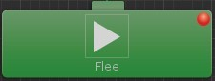

Right clicking on a task will bring up a menu which allows you to set a breakpoint. If a breakpoint is set on a particular task then Behavior Designer will pause Unity whenever that task is activated. This is useful if you want to see when a particular task is executed.

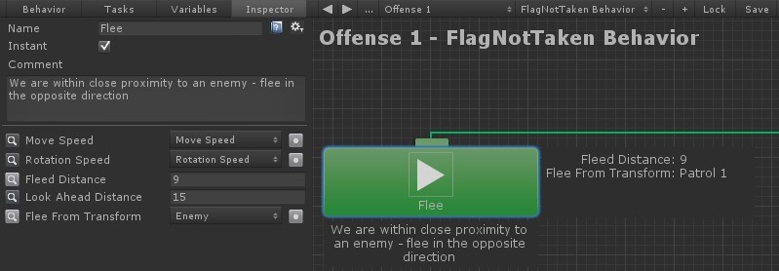

When a task is selected you have the option of watching a variable within the graph by clicking on the magnifying glass to the left of the variable name. Watched variables are a good way to see the value of a particular variable without having to have the task inspector open. In the example above the variables "Fleed Distance" and "Flee From Transform" are being watched and appear to the right of the Flee task.

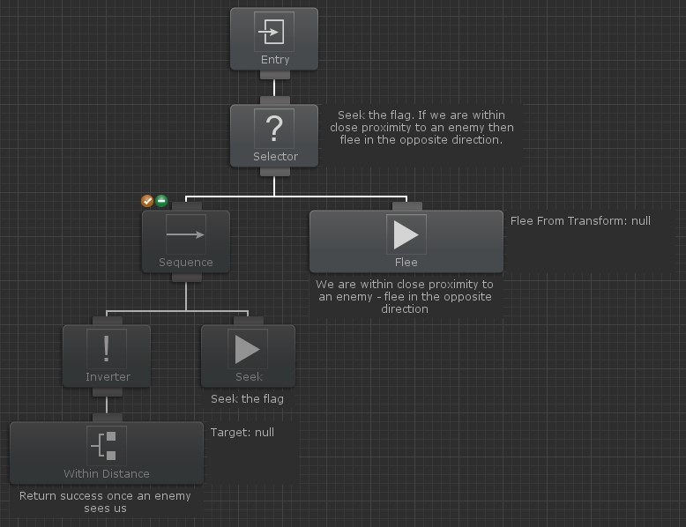

Sometimes you only want to focus on a certain set of tasks and prevent the rest from running. This is possible by disabling a set of tasks. Tasks can be disabled by hovering over the task and selecting the orange X on the top left of the task. Disabled tasks will not run and return success immediately. Disabled tasks appear in a darker color than the enabled tasks within the graph.

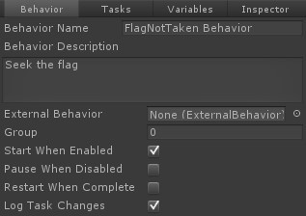

One more debugging option is to output to the console any time a task changes state. If “Log Task Changes” is enabled then you’ll see output to the log similar to the following:

GameObject - Behavior: Push task Sequence (index 0) at stack index 0 GameObject - Behavior: Push task Wait (index 1) at stack index 0

GameObject - Behavior: Pop task Wait (index 1) at stack index 0 with status Success GameObject - Behavior: Push task Wait (index 2) at stack index 0

GameObject - Behavior: Pop task Wait (index 2) at stack index 0 with status Success GameObject - Behavior: Pop task Sequence (index 0) at stack index 0 with status Success Disabling GameObject – Behavior

These messages can be broken up into the following pieces:

{game object name } – {behavior name}: {task change} {task type} (index {task index}) at stack index {stack index} {optional status}

{game object name} is the name of the game object that the behavior tree is attached to. {behavior name} is the name of the behavior tree. {task change} indicates the new status of the task. For example, a task will be pushed onto the stack when it starts executing and it will be popped when it is done executing . {task type} is the class type of the task. {task index} is the index of the task in a depth first search. {stack index} is the index of the stack that the task is being pushed to. If you have a parallel node then you’ll be using multiple stacks. {optional status} is any extra status for that particular change. The pop task will output the task status.

# Variables

One of the advantages of behavior trees are that they are very flexible in that all of the tasks are loosely coupled - meaning one task doesn't depend on another task to operate. The drawback of this is that sometimes you need tasks to share information with each other. For example, you may have one task that is determine if a target is Within Sight. If the target is within sight you might have another task Move Towards the target. In this case the two tasks need to communicate with each other so the Move Towards task actually moves in the direction of the same object that the Within Sight task found. In traditional behavior tree implementations this is solved by coding a blackboard. With Behavior Designer it is a lot easier in that you can use variables.

In our previous example we had two tasks: one that determined if the target is within sight and then the other task moves towards the target. This tree looks like:

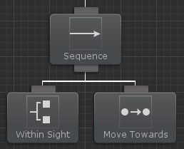

The code for both of these tasks is discussed in the Writing a New Task topic, but the part that deals with variables is in this variable declaration:

public SharedTransform target;

With the SharedTransform variable created, we can now create a new variable within Behavior Designer and assign that variable to the two tasks:

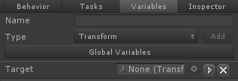

Switch to the task inspector and assign that variable to the two tasks:

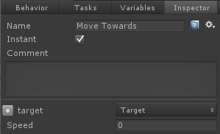

And with that the two tasks can start to share information! You can get/set the value of the shared variable by accessing the Value property. For example, target.Value will return the transform object. When Within Sight runs it will assign the transform of the object that comes within sight to the Target variable. When Move Towards runs it will use that Target variable to determine what position to move towards.

Looking at the variable within the inspector, if you look to the left of the delete button you'll see a triangle pointing to the right. This is the button for Variable Mappings.

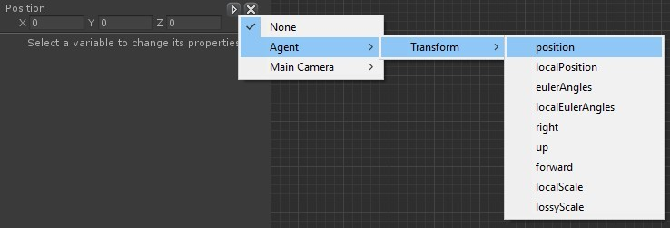

Variable Mappings allow your SharedVariable to map to a property of the same type. This allows you to quickly get or set a value on a MonoBehaviour component. As an example, lets say that we want to get the position of the agent. It is possible to use the Get Position task with a non-mapped variable, but that adds unnecessary tasks to your behavior tree. Instead, if you map the variable to the Transform.position property, whenever the value of the variable is accessed, it will instead use the property that it is mapped to. This allows you to get or set the position of the Transform without any extra tasks.

Behavior Designer supports both local and global variables. Global Variables are similar to local variables except any tree can reference the same variable. Variables can be referenced by non-Task derived classes by getting a reference to from the behavior tree.

The following shared variable types are included in the default Behavior Designer installation. If none of these types are suitable for your situation then you can create your own shared variable:

SharedBool SharedColor SharedFloat SharedGameObject SharedGameObjectList SharedInt SharedMaterial SharedObject SharedObjectList SharedQuaternion SharedRect SharedString SharedTransform SharedTransformList SharedVector2 SharedVector3 SharedVector4

# Global Variables

Global variables are similar to local variables except any behavior tree can access an instance of the same variable. To access global variables, navigate to the Window->Behavior Designer->Global Variables menu option or from within the Variables pane:

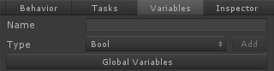

When a global variable is first added an asset file is created which stores all of the global variables. This file is created at /Behavior Designer/Resources

/BehaviorDesignerGlobalVariables.asset. You can move this file as long as it is still located in a Resources folder.

Global variables are assigned in a very similar way as local variables. In the task inspector, when you are assigning a global variable the global variables are located under the "Globals" menu item:

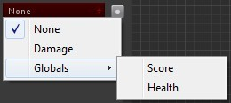

Global variables can also be accessed from non-Task derived objects.

# Creating Shared Variables

New Shared Variables can be created if you don't want to use any of the built in types. To create a Shared Variable, subclass the SharedVariable type and implement the following methods. The keyword OBJECT_TYPE should be replaced with the type of Shared Variable that you want to create.

[System.Serializable]

public class SharedOBJECT_TYPE : SharedVariable < OBJECT_TYPE >

{

public static implicit operator SharedOBJECT_TYPE(OBJECT_TYPE value) { return new SharedOBJECT_TYPE { Value = value }; }

}

It is important that the "Value" property exists. The variable inspector will show an error if the new Shared Variable is created incorrectly. Shared Variables can contain any type of object that your task can contain, including primitives, arrays, lists, custom objects, etc.

As an example, the following script will allow a custom class to be shared:

[System.Serializable] public class CustomClass

{

public int myInt; public Object myObject;

}

[System.Serializable]

public class SharedCustomClass : SharedVariable < CustomClass >

{

public static implicit operator SharedCustomClass(CustomClass value) { return new SharedCustomClass { Value = value }; }

}

# Accessing Variables from non-Task Objects

Variables are normally referenced by assigning the variable name to the task field within the Behavior Designer inspector panel. Local variables can also be accessed by non-Task derived classes (such as MonoBehaviour) by calling the methods

behaviorTree.GetVariable("MyVariable"); behaviorTree.SetVariable("MyVariable", value); behaviorTree.SetVariableValue("MyVariableName", value);

When setting a variable, if you want the tasks to automatically reference that variable then make sure a variable is created with that name ahead of time. The following code snippet shows an example of modifying a variable from a MonoBehaviour class:

using UnityEngine;

using BehaviorDesigner.Runtime;

public class AccessVariable : MonoBehaviour

{

public BehaviorTree behaviorTree;

public void Start()

{

var myIntVariable = (SharedInt)behaviorTree.GetVariable("MyVariable"); myIntVariable.Value = 42;

}

}

In the above example we are getting a reference to the variable named "MyVariable" within the Behavior Designer Variables pane. Also, as shown in the example, you can get and set the value of the variable with the SharedVariable.Value property.

Similarly, global variables can be accessed by getting a reference to the GlobalVariable instance:

GlobalVariables.Instance.GetVariable("MyVariable"); GlobalVariables.Instance.SetVariable("MyVariable", value);

# Conditional Aborts

Conditional aborts allow your behavior tree to dynamically respond to changes without having to clutter your behavior tree with many Interrupt/Perform Interrupt tasks. This feature is similar to the Observer Aborts in Unreal Engine 4. Most behavior tree implementations reevaluate the entire tree every tick. Conditional aborts are an optimization to prevent having to rerun the entire tree. As a basic example, consider the following tree:

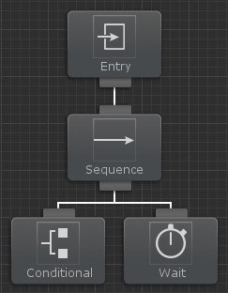

When this tree runs the Conditional task will return success and the Sequence task will start running the next child, the Wait task. The Wait task has a wait duration of 10 seconds. While the wait task is running, lets say that the conditional task changes changes state and now returns failure. If Conditional aborts are enabled, the Conditional task will issue an abort and stop the Wait task from running. The Conditional task will be reevaluated and the next task will run according to the standard behavior tree rules. Conditional aborts can be accessed from any Composite task:

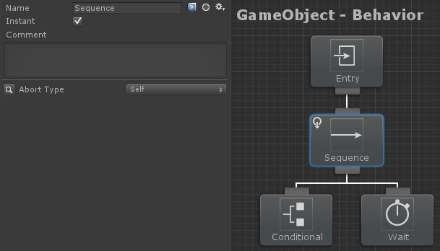

There are four different abort types: None, Self, Lower Priority, and Both.

# None

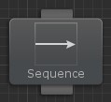

This is the default behavior. The Conditional task will not be reevaluated and no aborts will be issued.

# Lower Priority

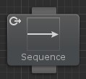

Behavior trees can be organized from more important tasks to least important. If a more important Conditional task changes status then can issue an abort that will stop the lower priority tasks from running.

# Self

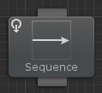

This is a self contained abort type. The Conditional task can only abort an Action task if they both have the same parent Composite task.

# Both

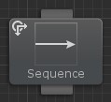

This abort type combines both self and lower priority

Conditional aborts can also be thought of the following way:

**Lower Priority:** will reevaluate when any task to the right of the current branch is active.

**Self:** will reevaluate when any task within the current branch is active.

**Both:** will reevaluate when any task to the right or within the current branch is active. The following example will use the lower priority abort type:

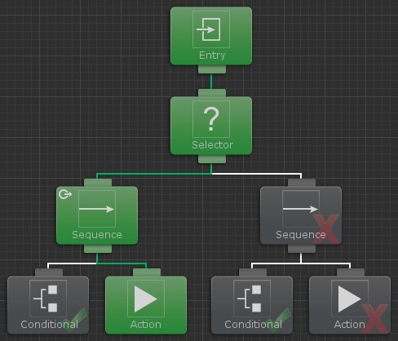

In this example the parent Sequence task of the left branch has an abort type of lower priority. Lets say that the left branch fails and moves the tree onto the right branch due to the Selector parent task. While the right branch is running, the very first Conditional task changes status to success. Because the task status changed and the abort type was lower priority the Action task that is currently running gets aborted and the original Conditional task is rerun.

The conditional task's execution status will have a repeater icon around the success or failure status to indicate that it is being reevaluated by a conditional abort:

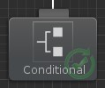

Conditional aborts can be nested beneath one another as well. For example, you may want to run a branch when one of two conditions succeed, but they both don't have to. In this example we will be using the Can See Object and Can Hear Object tasks. You want to run the action task when the object is either seen or heard. To do this, these two conditional tasks should be parented by a Selector with the lower priority abort type. The action task is then a sibling of the Selector task. A Sequence task is then parented to these two tasks because the action task should only run when either of the conditional tasks succeed. The Sequence task is set to a Lower Priority abort type so the two conditional tasks will continue to be reevaluated even when the tree is running a completely different branch.

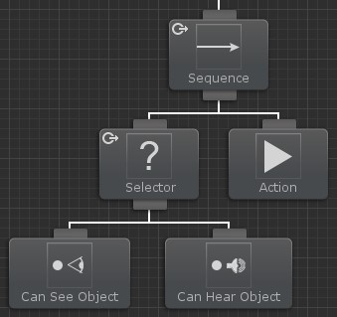

The important thing to note with this tree is that the Selector task must have an abort type set to Lower Priority (or Both). If it does not have an abort type set then the two conditional tasks would not be reevaluated.

# Events

The event system within Behavior Designer allows your behavior trees to easily react to changes. This event system can trigger an event via code or through behavior tree tasks.

Events can be signaled through the behavior tree with the Send Event and the Has Received Event tasks. When an event should be signaled, the Send Event task should be used. The Has Received Event task is a conditional task and will return success as soon as the event has been received. An event name can be specified for both of these tasks.

In addition to being able to send events via the behavior tree, events can be sent through code. The BehaviorTree.SendEvent method will allow you to send an event to the specified behavior tree. For example:

var behaviorTree = GetComponent< BehaviorTree >(); behaviorTree.SendEvent< object >("MyEvent", Vector3.zero);

In this example the "MyEvent" event will be sent to the behavior tree component with a parameter value of Vector3.zero. If the behavior tree contains the Has Received Event task then it will react accordingly.

You are also able to receive events from outside the behavior tree. To continue with the "MyEvent" example, you can receive this event by using the BehaviorTree.RegisterEvent method. BehaviorTree.UnregisterEvent will stop listening for that event.

public void OnEnable()

{

var behaviorTree = GetComponent< BehaviorTree >(); behaviorTree.RegisterEvent< object >("MyEvent", ReceivedEvent);

}

public void ReceivedEvent(object arg1)

{

}

public void OnDisable()

{

var behaviorTree = GetComponent< BehaviorTree >(); behaviorTree.UnregisterEvent< object >("MyEvent", ReceivedEvent);

}

# External Behavior Trees

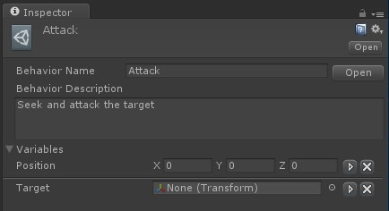

In some cases you may have a behavior tree that you want to run from multiple objects. For example, you could have a behavior tree that patrols a room. Instead of creating a separate behavior tree for each unit you can instead use an external behavior tree. An external behavior tree is referenced using the Behavior Tree Reference task. When the original behavior tree starts running it will load all of the tasks within the external behavior tree and act like they are its own. Any SharedVariable within the external tree of the same name and type of its parent tree will automatically be overridden. For example, if the parent tree has a SharedInt named "MyInt" with a value of 7, and the External Tree has a SharedInt named "MyInt" with a value of 0, when the tree runs MyInt will have a value of 7 within the External Tree.

# Networking

Behavior Designer supports Unity's networking system introduced with Unity 5.1. Networking is a complex topic so it is highly recommended that you first go through Unity's networking documentation before continuing.

Shared Variables can automatically be synchronized over the network from the server to the client. This can be enabled by opening the details of the variable and selecting "Network Sync":

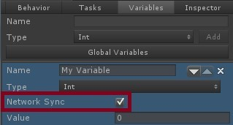

The ENABLE_MULTIPLAYER compiler definition must be added for the variables to sync correctly.

Due to a current networking limitation, ClientRPC calls cannot be overloaded so the type has to be known ahead of time. This means that only the following types of variables can be synchronized:

bool Color float

GameObject int Quaternion Rect

string Transform Vector2 Vector3 Vector4

The Behavior component from the runtime source code must be used in order to allow the variables to be synchronized. This is a result of a current Unity networking bug. ClientRPC calls cannot be called on the parent class from a subclass. A bug report has been submitted and are waiting for a fix. This bug manifests itself by displaying the following warning in the console:

*Failed to invoke RPC [RpcPath]([ObjectID]) on netID [NetID]*

Where [RpcPath] is the method path, [ObjectID] is the ID of the object, and [NetID] is the network ID.

# Referencing Tasks

When writing a new task, in some cases it is necessary to access another task within that task. For example, TaskA may want to get the value of TaskB.SomeFloat. To accomplish this, TaskB needs to be referenced from TaskA. In this example TaskA looks like:

using UnityEngine;

using BehaviorDesigner.Runtime.Tasks;

public class TaskA : Action

{

public TaskB referencedTask;

public void OnAwake()

{

Debug.Log(referencedTask.SomeFloat);

}

}

TaskB then looks like:

using UnityEngine;

using BehaviorDesigner.Runtime.Tasks;

public class TaskB : Action

{

public float SomeFloat;

}

Add both of these tasks to your behavior tree within Behavior Tree and select TaskA.

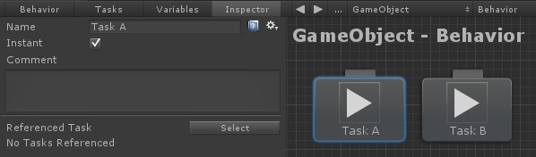

Click the select button. You'll enter a link mode where you can select other tasks within the behavior tree. After you select Task B you'll see that Task B is linked as a referenced task:

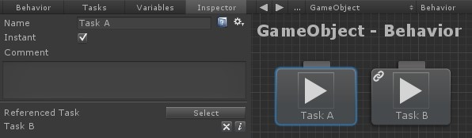

That is it. Now when you run the behavior tree TaskA will be able to output the value of TaskB's SomeFloat value. You can clear the reference by clicking on the “x” to the right of the referenced task name. If you click on the “i" then the linked task will highlight in orange:

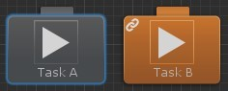

Tasks can also be referenced using an array:

public class TaskA : Action

{

public TaskB[] referencedTasks;

}

# Object Drawers

Object Drawers are very similar to the Unity feature Property Drawers. Object drawers allow you to customize the look of different objects within the inspector. As an example, we will modify the Shared Custom Object example found in the Creating Your Own Shared Variable topic. With the default inspector, the SharedCustomClass variable looks like the following in the inspector:



For this example, we will limit the range of the integer between 0 and 10 using object drawers:



The following object drawer was used to accomplish this (this script goes in an Editor folder):

using UnityEngine; using UnityEditor;

using BehaviorDesigner.Editor;

[CustomObjectDrawer(typeof(CustomClass))] public class CustomClassDrawer : ObjectDrawer

{

public override void OnGUI(GUIContent label)

{

var customClass = value as CustomClass;

EditorGUILayout.BeginVertical();

if (FieldInspector.DrawFoldout(customClass.GetHashCode(), label)) { EditorGUI.indentLevel++;

customClass.myInt = EditorGUILayout.IntSlider("Integer", customClass.myInt, 0, 10);

customClass.myObject = EditorGUILayout.ObjectField("Object", customClass.myObject, typeof(UnityEngine.Object), true); EditorGUI.indentLevel--;

}

EditorGUILayout.EndVertical();

}

}

The only method that you need to override for object drawers to work is the OnGUI(GUIContent label) method. The label field is the name of the field that is being drawn. Just like property drawers, you can specify a object drawer by the class type or by attributes. The example above is using the class type method.

As another example, we will convert the Ranged Attribute used in Unity's example to a Object Drawer. First we need to create the attribute:

using UnityEngine;

using BehaviorDesigner.Runtime.Tasks;

public class RangeAttribute : ObjectDrawerAttribute

{

public float min; public float max;

public RangeAttribute(float min, float max)

{

this.min = min; this.max = max;

}

}

Now that the attribute is created, we need to create the actual object drawer (this script goes in an Editor folder):

using UnityEngine; using UnityEditor;

using BehaviorDesigner.Editor;

[CustomObjectDrawer(typeof(RangeAttribute))] public class RangeDrawer : ObjectDrawer

{

public override void OnGUI(GUIContent label)

{

var rangeAttribute = (RangeAttribute)attribute;

value = EditorGUILayout.Slider(label, (float)value, rangeAttribute.min, rangeAttribute.max);

}

}

Once both of these have been created, we can use it within a task:

using UnityEngine;

using BehaviorDesigner.Runtime;

using BehaviorDesigner.Runtime.Tasks;

public class NewAction : Action

{

[Range(5, 10)]

public float rangedFloat;

public override TaskStatus OnUpdate()

{

Debug.Log(rangedFloat); return TaskStatus.Success;

}

}

This will show up in the task inspector as:



# Variable Synchronizer

Shared Variables are great for sharing data across tasks and behavior trees. However, in some cases you want to share to same variables with non-behavior tree components. As an example, you may have a GUI Controller component which manages the GUI. This GUI Controller displays a GUI element indicating whether or not the agent being controlled by the behavior tree is alive. It does this by having a boolean which says whether or not the agent is alive:

public bool isAlive { get; set; }

With the Variable Synchronizer component, you can automatically keep this boolean and the corresponding Shared Variable synchronized with each other.

To setup the Variable Synchronizer, first make sure you have created the Shared Variables that you want to synchronize. For this example we created three Shared Variables:

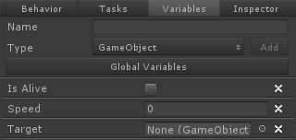

Following that, add the Behavior Designer/Variable Synchronizer component to a GameObject.

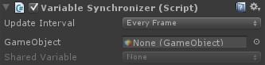

Next, start adding the Shared Variable that you want to keep synchronized. For this example we are going to add the Is Alive variable that was previously mentioned.

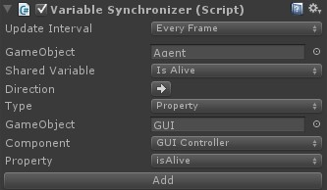

1. Specify the GameObject which contains the behavior tree that has the Shared Variable that you want to synchronize.
2. Select from the popup box which Shared Variable you want to use.
3. Specify a direction. If the arrow is pointing to the left then you are setting the Shared Variable value. If the arrow is pointing to the right then you are getting the Shared Variable value.
4. Specify the type of synchronization. Currently the following types are supported: Behavior Designer, Property, Animator, and PlayMaker.
5. The remaining steps will depend on the type of synchronization selected. In this example Property was selected so you'll need to select the component which contains the property that you want to synchronize with the Shared Variable.
6. Click Add.

Once added the Is Alive Shared Variable will set the isAlive property at an interval specified by Update interval. The following screenshot contains a few more synchronized variables:

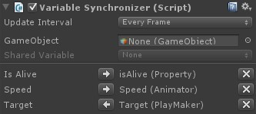

The Is Alive Shared Variable is setting the isAlive property.

The Speed Share Variable is setting the Speed Animator parameter.

The Target Shared Variable is being set by the Target PlayMaker variable.

# Task Attributes

Behavior Designer exposes the following task attributes: HelpURL, TaskIcon, TaskCategory, TaskDescription and LinkedTask.

If you open the task inspector panel you will see on the doc icon on the top right. This doc icon allows you to associate a help webpage with a task. You make this association with the HelpURL attribute:

[HelpURL("<http://www.opsive.com/assets/BehaviorDesigner/documentation.php?id=27>")] public class Parallel : Composite

{

The HelpURL attribute takes one parameter which is the link to the webpage. In addition to the HelpURL, a task can have the TaskIcon attribute:

[TaskIcon("Assets/Path/To/{SkinColor}Icon.png")] public class MyTask : Action

{

Task icons are shown within the behavior tree and are used to help visualize what a task does. Paths are relative to the root project folder. The keyword {SkinColor} will be replaced by the current Unity skin color, "Light" or "Dark".

Organization starts to become an issue as you create more and more tasks. For that you can use TaskCategory attribute:

[TaskCategory("Common")] public class Seek : Action

{

This task will now be categorized under the common category:

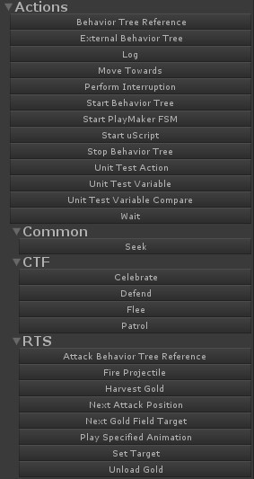

Categories may be nested by separating the category name with a slash:

[TaskCategory("RTS/Harvester")] public class HarvestGold : Action

{

The TaskDescription attribute allows you to show your class-level comment within the graph view. For example, the sequence description starts out with:

[TaskDescription("The sequence task is similar to an \"and\" operation "] public class Sequence : Composite

{

This description will then be shown in the bottom left area of the graph:

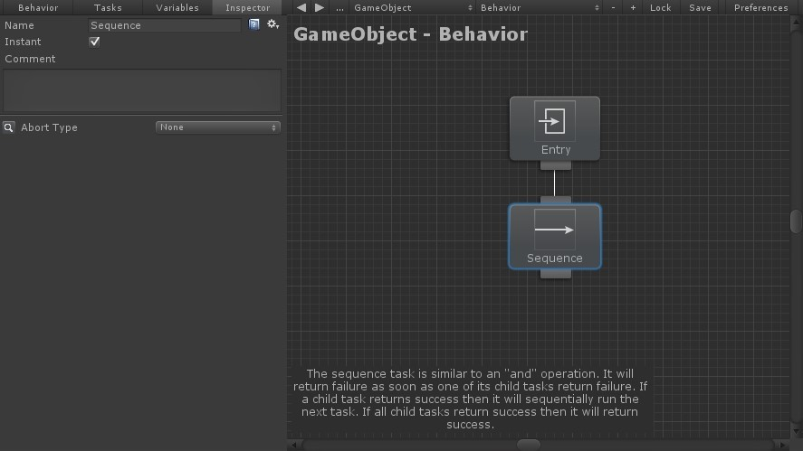

Variables are great when you want to share information between tasks. However, you'll notice that there is no such thing as a "SharedTask". When you want a group of tasks to share the same tasks use the LinkedTask attribute. As an example, take a look at the task guard task. When you reference one task with the task guard, that same task will reference the original task guard task back. Linking tasks is not necessary, it is more of a convince attribute to make sure the fields have values that are synchronized. Add the following attribute to your field to enable task linking:

[LinkedTask]

public TaskGuard[] linkedTaskGuards = null;

To perform a link within the editor perform the same steps as referencing another task.

# Third Party Integrations

Behavior Designer includes many tasks which integrate with third party assets. For most of those integrations, no extra steps are required and they can be added to a behavior tree and then have their values assigned. However, the following integrations take a small amount of more work in order to fully work:

ICode

Dialogue System Motion Controller PlayMaker Realistic FPS

Third Person Controller UFPS

uScript

# ICode

ICode allows you to create state machines with an interface similar to the mecanim animator interface. Behavior Designer is integrated with ICode by allowing you to start and stop these state machines from within a behavior tree, as well as run a state machine as a conditional task. ICode also includes a set of actions that allow you to start and stop a behavior tree from within the state machine. All of the ICode integration files located on the samples page.

To get started, first make sure you have AI For Mecanim installed. Next, import AIForMecanimAssets.unitypackage:

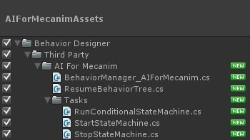

Once those files are imported you are ready to start creating behavior trees with ICode! To get started, create a very basic tree with a sequence task who has two Start State Machine child tasks:

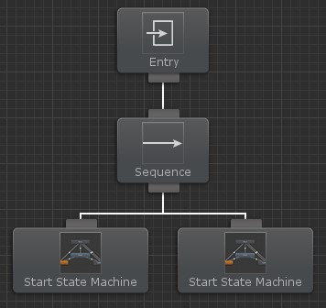

Next add two State Machine Behaviour components to the same GameObject that you added the behavior tree to. Since there are multiple State Machine Behaviours on the same GameObject ensure you have set the group number. In addition, assign the State Machine field to a new StateMachine and prevent the State Machine from starting when enabled.

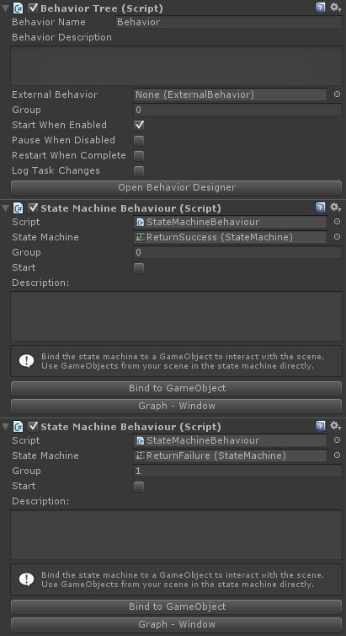

Open the AI For Mecanim editor and create a new state machine using one of the StateMachine objects that was just assigned to the State Machine Behaviour. Behavior Designer starts the state machine from the "Default" state so create a new state and ensure it is orange indicating that it is the default state.

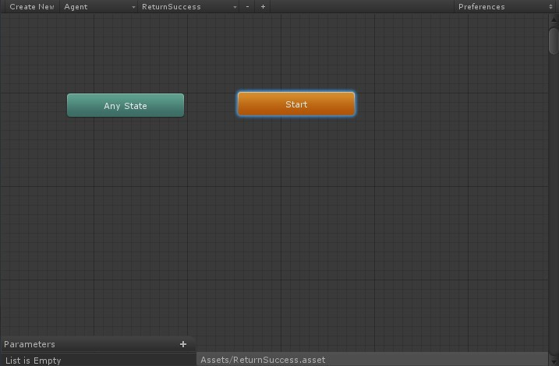

Create a new bool parameter (named Return Status) and two more states (named Set Status and Resume Behavior Tree). Add transitions from Start to Set Status and Set Status to Resume Behavior Tree. This state machine will simply set a bool to indicate the return status, wait a second, and finally resume the behavior tree.

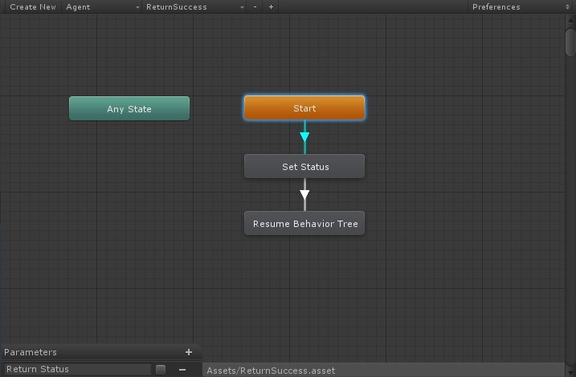

Select the Start state and view the State Inspector. For this state we only need to add a conditional which exits the state immediately.

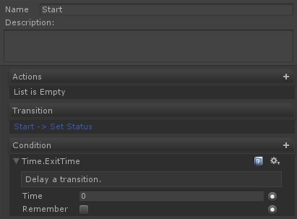

Select the Set Status state and view the State Inspector. Add the Parameter -> Set Bool action. This action will set the Return Status parameter to true. In addition, add a condition that exits the state after 1 second.

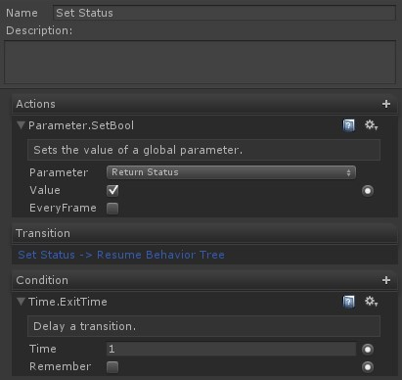

Select the Resume Behavior Tree state and view the State Inspector. Add the Behavior Designer -> Resume Behavior Tree action. Ensure you have set the Success variable to the Return Status parameter.

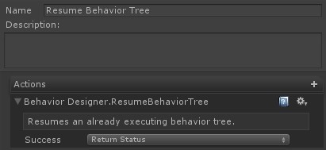

We are done setting up this state machine. Perform the same steps for the second state machine that we created earlier, only this time set the Return Status parameter to false within the Set Bool action.

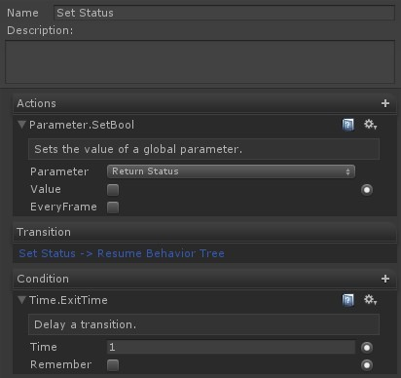

Open your behavior tree in Behavior Designer again and assign the Target Game Object and Group to point to the first state machine.

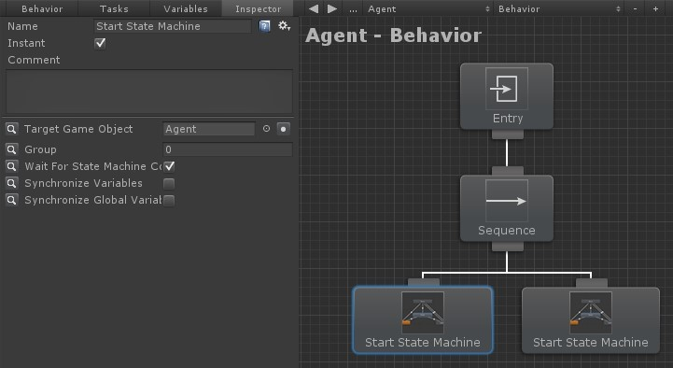

Set the fields of the second state machine task as well, making sure the group is set to 1.

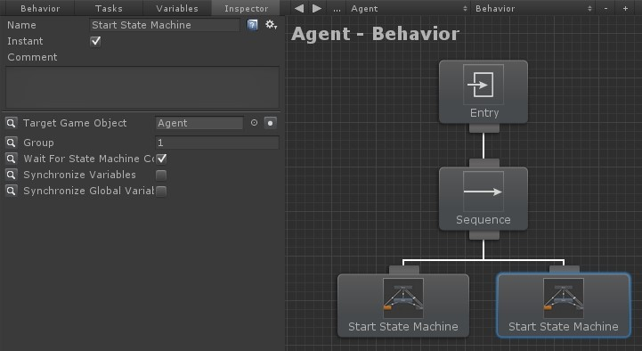

We are now ready to run the behavior tree with ICode integration! The first state machine's task will return success after 1 second because we set the Return Status parameter to true within the Set Status action. Similarly, the second state machine task will run for 1 second only this time it was return failure because the Return Status was set to false.

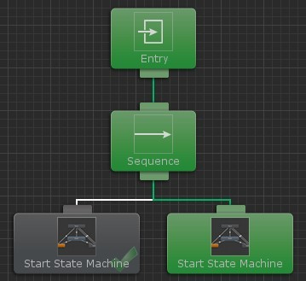

The behavior tree will never get to the second state machine if you were to swap the state machine tasks because the first state machine task returns failure.

# Dialogue System

The Dialogue System is a complete dialogue system for Unity. Behavior Designer is integrated with the Dialogue System by allowing you to manage conversations, barks, sequences, and quests within your behavior tree. Also, Dialogue System is integrated with Behavior Designer so it can synchronize variables with Lua and start/stop behavior trees with sequence commands. More information on this side of the integration can be found here. All of the Dialogue System integration files are located on the samples page.

To get started, first make sure you have Dialogue System for Unity installed. Next, import DialogueSystemAssets.unitypackage:

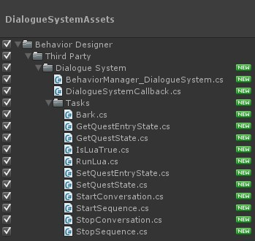

Once those files are imported you are ready to start creating behavior trees with the Dialogue System! To get started, create a very basic tree with a sequence task which has a Wait task and a Start Conversation task:

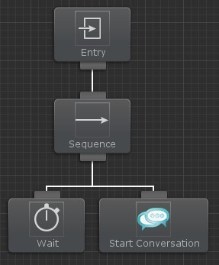

When the Dialogue System finishes with a conversation or sequence it will callback to Behavior Designer to let Behavior Designer know that it is done. In order for this to occur the Dialogue System Callback component must be added to the same GameObject that your behavior tree is on:

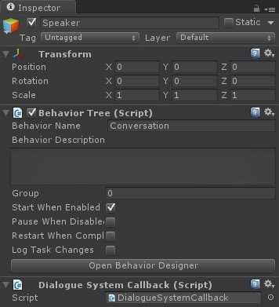

Now we are ready to start creating the actual conversion. Create a new Dialogue System Database and create a basic conversation:

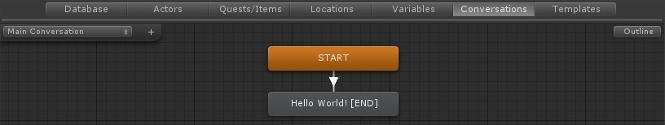

Make note of the conversation name because that will be needed later. Assign that database to the Dialogue System Controller:

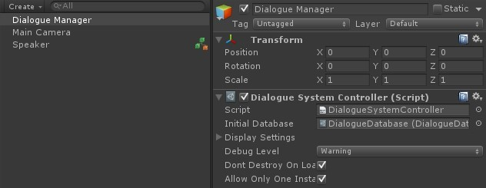

The last step is to simply assign the values within the Start Conversation task. The only two values that are required are the conversation name and the actor GameObject:

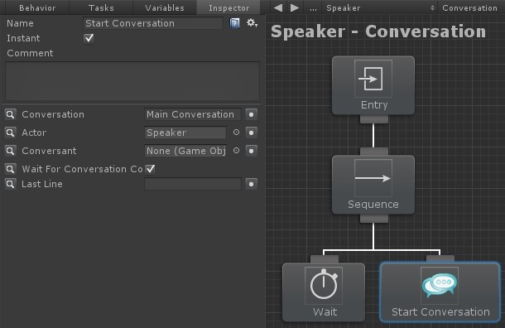

Once those values have been assigned, hit play and you'll see the text "Hello World" appear at the top of the game screen:

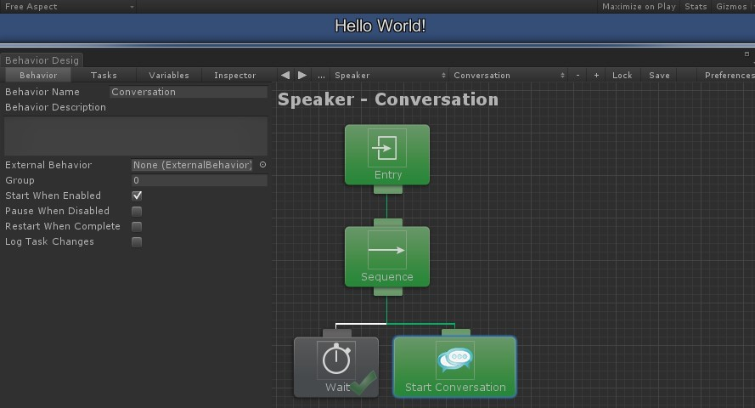

This topic hardly scratches the surface for what is possible with Behavior Designer / Dialogue System integration. For a more complex example, take a look at the Dialogue System sample project.

# Motion Controller

Motion Controller allows you to add any type of motion to your character. With Behavior Designer integration, your agent will come alive by walking, running, jumping, and climbing as if they were controlled by another player.

We were contacted by Tim from ootii on integrating Motion Controller with Behavior Designer. Unlike other integrations, Tim wanted more than just task/script integration: he wanted to create a complete tree that brings a character to life to really showcase the integration between the two assets. After a couple of months of work, we have that tree completed.

In the Goblin Life sample scene, you control a goblin. This goblin can move with the included Motion Controller actions such as walking, jumping, and climbing. This part isn't new. What is new is that your goblin character has many goblins surrounding him. All of these goblins are controlled by a behavior tree with tasks that are integrated with Motion Controller. This is a zoomed out view of that behavior tree:

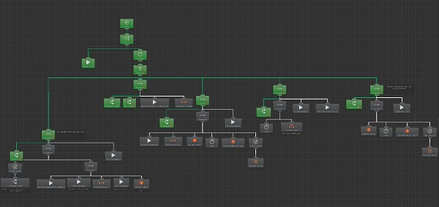

Because some of the tasks use layers, we had to place the project in a zip file instead of the standard Unity package. Once you have downloaded this zip file *do not open* the GoblinLife scene yet. First import Motion Controller and Behavior Designer. Once those two packages are imported download the Motion Controller tasks on the integrations page.

Import the Motion Controller Unity package. This package contains the Motion Controller tasks as well as a overview PDF which describes the integration.

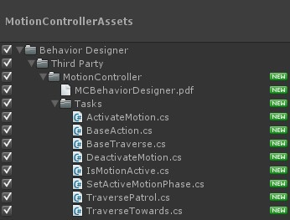

Once you have imported these three assets you can open the Goblin Life scene. If you accidentally opened the Goblin Life scene ahead of time it's no problem, just make sure you reload the scene before you hit play in Unity.

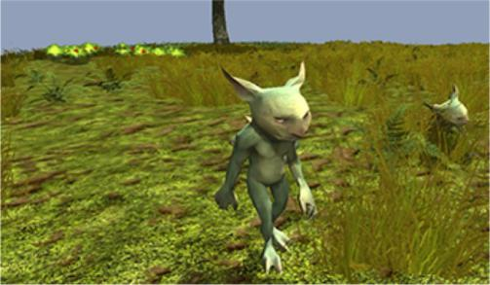

Once you play the scene you'll see that there are several activities that the goblins take part in. They can eat, sleep, patrol, and gamble when they become bored. This behavior tree makes use of conditional aborts, external behavior trees, and global variables.

The root of the tree contains a parallel task which has two children: the Goblin Live task and a selector task which contains the various actions for the goblins.

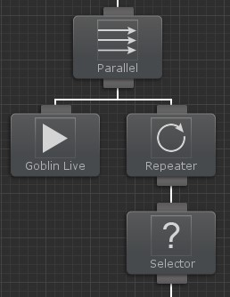

The Goblin Live task updates Shared Variables in order to determine the current state of the goblin.

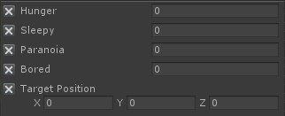

As an example, every tick the hunger variable will be updated by the Hunger Increase Rate. This causes the hunger variable to grow as time goes on, and the Is Eat Time task further down the tree will check to see if that hunger value is greater than a specified value.

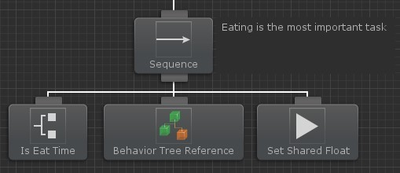

The sequence task has a lower priority conditional abort setup so when the hunger value is greater than the specified value it will abort whatever task is currently running and start the external tree within the behavior tree reference task. Once that external tree finishes executing the Set Shared Float task will reset the hunger value back to 0.

The Goblin Life tree contains four other branches similar to this one. They are arranged from highest priority to lowest priority: eat, sleep, patrol, move close to another goblin, and gamble. Each parent composite task of these branches have a conditional abort set the Lower Priority so that branch will always take priority over a lower branch. The only branch that is unique is the Patrol branch. The Patrol branch uses a global variable in order to determine if the goblin should go on patrol. If another goblin is on patrol then the current goblin should not start patrolling, and the global variable helps with this decision.

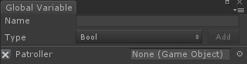

Within each branch is a set of Motion Controller actions that do the actual movement. For example, here is the Sleep branch:

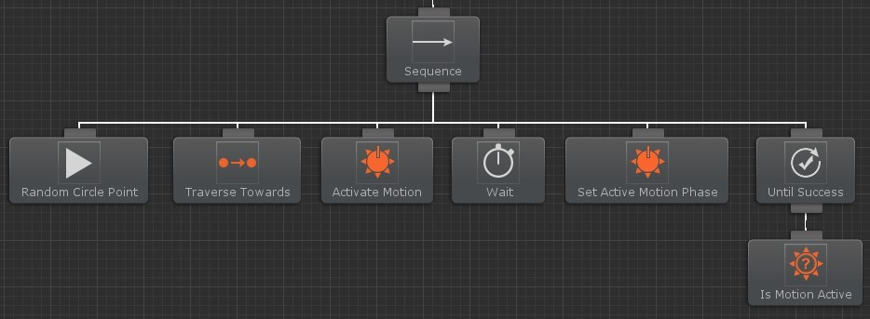

These tasks are processed in the following order:

1. Random Circle Point finds a random location based on a center point and a radius.
2. Traverse Towards is a Motion Controller action that has the goblin walk towards the random location found earlier. If there's an obstacle in his way, he'll climb over it.
3. Activate Motion is a Motion Controller action that plays a specific motion. In this case, 'Lay Down and sleep'.
4. Wait for the goblin to finish sleeping.
5. Set Active Motion Phase is a Motion Controller action that progresses a motion forward. In this case, it's time to tell the goblin to wake up.
6. Waiting until the wake up portion of the motion finishes.
7. Is Motion Active is a condition we’re check to see if we've finished waking up. Once we're done, #6 finishes successfully and the whole sequence is complete.

The rest of the branches are setup similarly. For a full listing of all of the Motion Controller tasks take a look at this topic.

# PlayMaker

PlayMaker is a popular visual scripting tool which allows you to easily create finite state machines. Behavior Designer integrates directly with PlayMaker by allowing PlayMaker to carry out the action or conditional tasks and then resume the behavior tree from where it left off. PlayMaker integration files are located on the samples page because PlayMaker is not required for Behavior Designer to work.

To get started, first make sure you have PlayMaker installed. Next, import PlayMakerAssets.unitypackage:

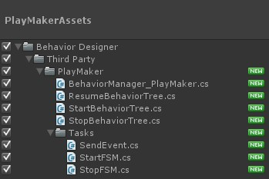

Once those files are imported you are ready to start creating behavior trees with PlayMaker! To get started, create a very basic tree with a sequence task who has two Start FSM child tasks:

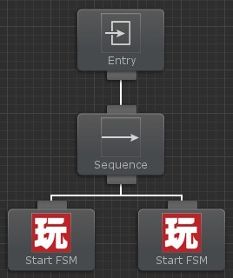

Next add two PlayMaker FSM components to the same game object that you added the behavior tree to.

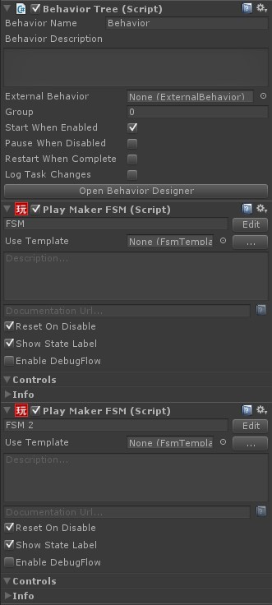

Open PlayMaker and start creating a new FSM. This FSM is going to be a simple FSM to show how Behavior Designer interacts with PlayMaker. For a more complicated FSM take a look at the FPS sample project. Behavior Designer starts the PlayMaker FSM by sending it an event. Create this event by adding a new state called “Behavior

Tree Listener” and adding a new global event called “StartFSM”. The event must be global otherwise Behavior Designer will never be able to start the FSM.

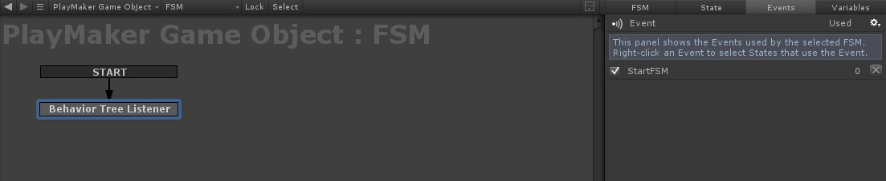

Add a transition from that event along with a wait state, a set bool state, and a resume behavior tree state. Make sure you transition from the Resume Behavior Tree state to the Behavior Tree Listener state so the FSM can be started again from Behavior Designer.

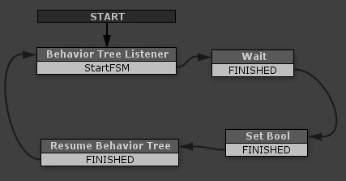

Create a new variable within the Set Bool state and set that value to true.

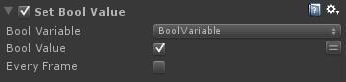

Then within the Resume Behavior Tree state we want to return success based off of that bool value:



That's it for this FSM. Create the same states and variables for the second FSM that we created earlier. Do not set the bool variable to true for this FSM.

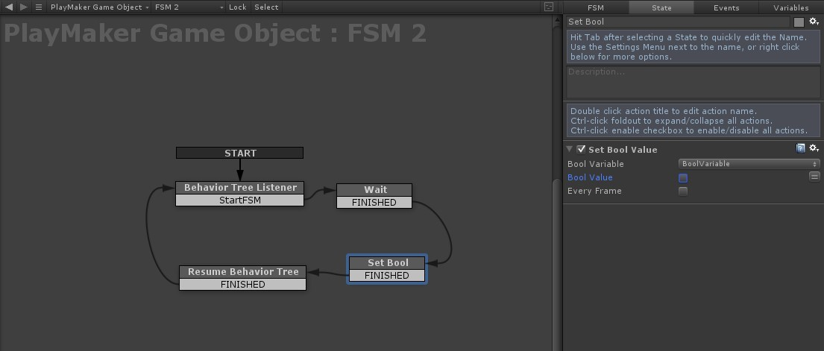

We are now done working in PlayMaker. Open your behavior tree back up within Behavior Designer. Select the left PlayMaker task and start assigning the values to the variables. PlayMaker Game Object is assigned to the game object that we added the PlayMaker FSM components to. FSM Name is the name of the PlayMaker FSM. Event name is the name of the global event that we created within PlayMaker.

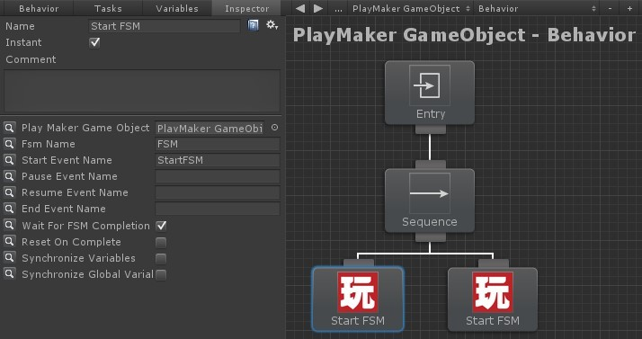

Now we need to assign the values for the right PlayMaker task. The values should be the same as the left PlayMaker task except a different FSM Name.

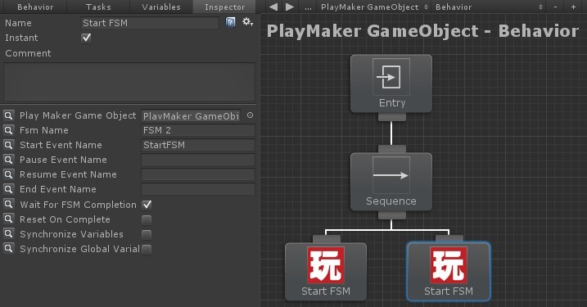

That's it! When you hit play you’ll see the first PlayMaker task run for a second and then the second PlayMaker task will start running.

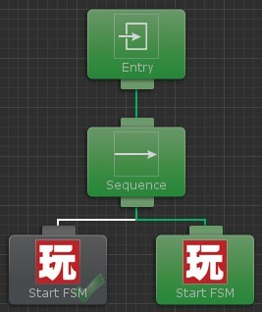

If you were to swap the tasks so the second PlayMaker task runs before the first PlayMaker FSM, the behavior tree will never get to the first PlayMaker FSM because the second PlayMaker FSM returned failure and the sequence task stopped executing its children.

# Realistic FPS

Realistic FPS Prefab gives you a quick way to implement the core FPS features quickly. The Behavior Designer integration with RFPS allows you to take damage from a RFPS player as well as allow the RFPS agent to shoot at the player. The AI component within RFPS has many dependencies so this integration will not execute any code from that component. The AI component is still required because the RFPS Character Damage component requires it. Two manual steps are required so Behavior Designer to take control. Open the AI.cs file found in the RFPS package at RFPSP/Scripts/AI. Find the following method and add a public virtual to it:

void Start(){

To:

public virtual void Start(){

The last change is within RFPSP/Scripts/Weapons/WeaponBehavior.cs. Within the HitObject method the following lines need to be changed:

if(hit.collider.gameObject.GetComponent() && hit.collider.gameObject.GetComponent().enabled){

to if(hit.collider.gameObject.GetComponent()){ and

if(hit.collider.gameObject.GetComponent() && hit.collider.gameObject.GetComponent().AIComponent.enabled){

to

if(hit.collider.gameObject.GetComponent()){

Since the AI component is disabled the Weapon should not check that it is enabled. The last step is to download the RFPS integration files from the samples page. Once the files have been imported the laststep is the replace the RFPS AI component with the AIAgent component found in Behavior Designer/Third Party/Realistic FPS Prefab:

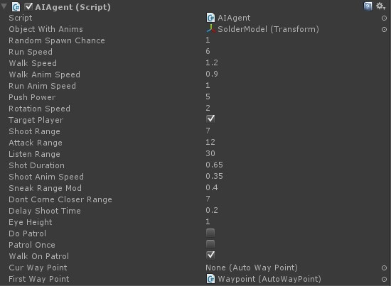

The AIAgent component is a very small class which disables all of the AI functions from running. This will allow the behavior tree to directly control the AI. That's all that is required! The behavior tree is now able to control the Realistic FPS agent.

# Third Person Controller

The Third Person Controller is the ultimate framework for any third person genre such as third person shooter, adventure, RPG, etc. Both Behavior Designer and the Movement Pack are integrated with the Third Person Controller allowing for realistic AI agents. The Third Person Controller tasks and sample project can be downloaded from the samples page and the Movement Pack integration files from the Movement Pack integrations page.

The Third Person Controller sample project contains a complete behavior tree that gives an example of how to create a realistic enemy agent with a behavior tree. This sample project can be played on the AI Demo page from the Third Person Controller webpage.

The goal of this behavior tree is to have the agent react when he sees, hears, or is shot by the player. In addition, the agent should go get health or ammo when he is running low. When the agent loses sight of the player he should search for the player at the last known position. When the agent is not aware of the player at all he should patrol a set of waypoints. This is a screenshot of the entire behavior tree (click to enlarge):

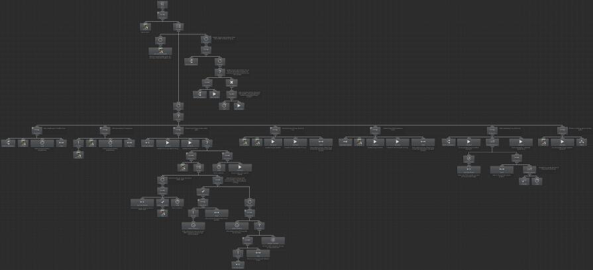

This tree looks complicated but it really is easy to understand once you break the tree up into the different branches. When the tree starts the Is Alive task is the very first task that runs.

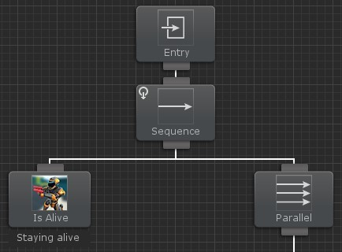

This task is parented by a Sequence task so the tree will continue execution one child at a time, from left to right. Conditional aborts are used on the Sequence task to reevaluate the Is Alive task every tick. This setup will stop the tree from executing when the agent dies.

After Is Alive is done executing a Parallel task is used to run branches at once. The Get Health branch is the smallest branch that is run by this Parallel task:

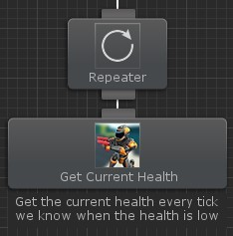

A Repeater task is used to reevaluate the Get Health task every tick. This is done so the behavior tree will have the current health value of the agent every time the tree updates. This value is used by a different branch.

In addition to the Get Health branch, the Update Position branch is executed by the parent Parallel task:

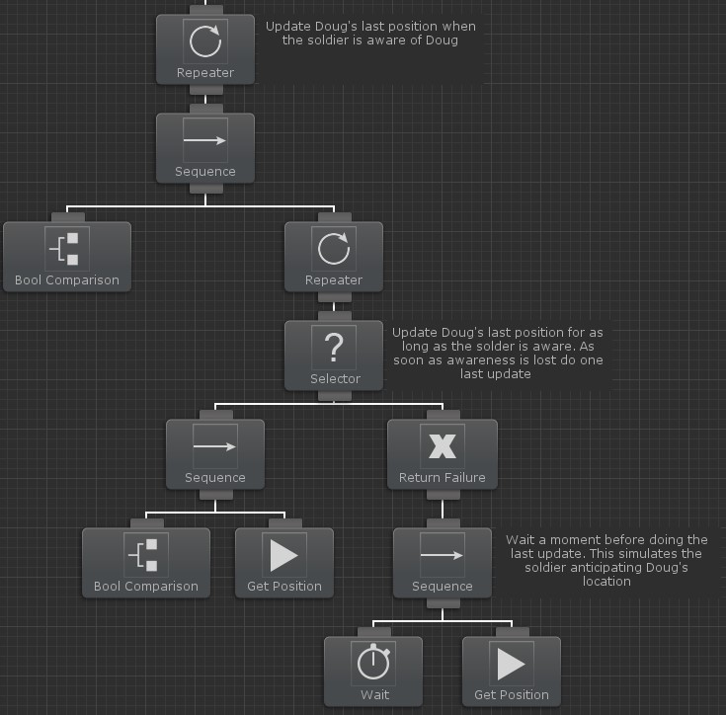

Similar to the Get Health task, the Update Position branch uses a Repeater task so the branch is executed every tick. The first action task that runs is a Bool Comparison task. This task will compare the Update Position Shared Variable with a true boolean value. When Update Position is equal to true the Bool Comparison task will return true and allow the parent Sequence task to run the next child (in this case the next child is another Repeater task).

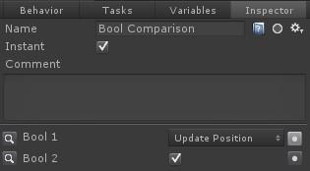

The Update Position variable is set to true when the agent starts to seek the player because of an event such as being able to see, hear, or is shot by the player. When this happens the Last Position Shared Variable should be updated to the player's position. The tasks under the second Repeater task do this update. A Selector task is used to parent the next set of branches. The position should only be updated for as long as the Update Position variable is true. The left branch under the Selector accomplishes this. Because the Selector is parented by a Repeater task this branch will be executed every tick for as long as Update Position is true. As soon as Update Position is set to false (because the agent lost sight of the player), the Bool Comparison task will return failure and the right branch will run.

This right branch uses two new tasks: the Return Failure task and Wait task. The very first action task that runs is the Wait task. When the agent loses sight of the player he will start to search for the player at the last known location. The Wait task along with the Get Position task simulates the agent anticipating the player's location a short amount of time after the agent loses sight of the player. This is useful for example when the player drops from a platform and the agent loses sight of the player. Before the player drops from the platform the last known location is on the platform so when the agent loses sight of the player he would search for the player on top of the platform. However, he should instead search for the player on the ground below the platform so this branch simulates that behavior. This branch is parented by the Return Failure task so the entire Update Position branch doesn't end. When the agent is done updating the position the tree should go back to the beginning and continuously check against the Bool Comparison task.

The final branch that executes under the Parallel task can be considered the heart of the tree and provides the actual functionality for the agent (click to enlarge):

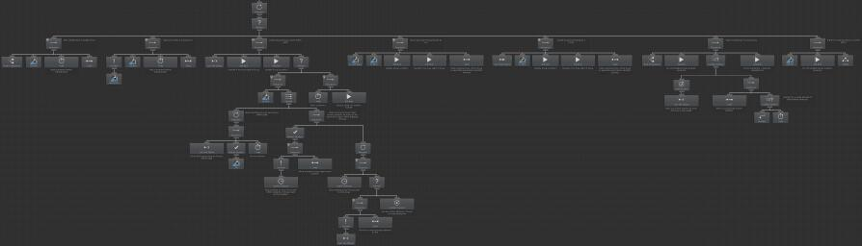

Similar to the other two branches, this branch is parented by a Repeater task so it will continue to be reevaluated even if a child branch returns success. The Selector task is a child of the Repeater task to allow the next child branch to run if the previous child branch returns failure. This brings up an important point in designing your behavior tree - since behavior trees are executed in depth first search order, the behavior tree should be designed with the highest priority branches on the left followed by the lower priority branches to the right. In this tree the highest priority branch is to get health if running low or to get ammo if running low. The lowest priority branch is to patrol.

Conditional aborts are used so the conditional tasks are reevaluated every tick. This allows the agent to seek for a health pack if his health is low even though the patrol task is running, for example. The Health branch is the furthest on the left because it is the most important:

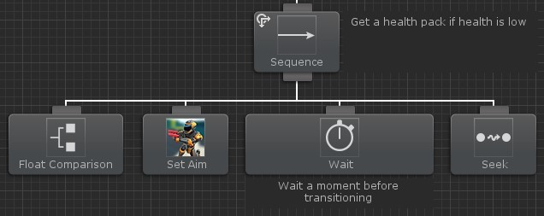

The Float Comparison task compares the Current Health Shared Variable with another float to determine if the agent is running low on health. When the agent is low on health the Set Aim task will run which will put the agent in a non-aiming state. The agent is only aiming when he is firing on the player so this task isn't necessary in all cases but it doesn't hurt to run. Following the Set Aim task, the Wait task will wait a small amount of time to make the transition smoother between the agent's last active task and the current task. The Seek task is then used to move the agent to the health pack. As soon as the agent picks up the health pack this branch will return failure because of the original Float Comparison task and a Both conditional abort set on the parent Sequence task.

If the agent does not need health the next highest priority item is to get ammo if the agent is out of ammo. This branch is setup very similarly to the Health branch:

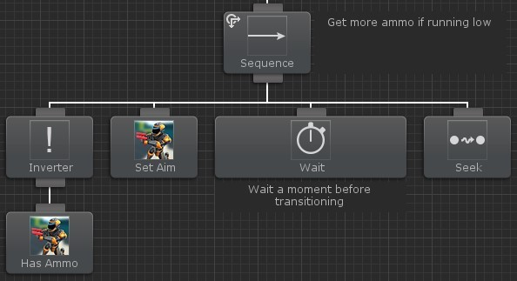

The Has Ammo conditional task is reevaluated every tick to determine if the agent has ammo. This task is parented by an Inverter task because this branch should only execute when Has Ammo returns failure, rather than success. In most cases the agent is going to have ammo so Has Ammo will return success. However, this branch should only run when the agent does not have ammo so an Inverter task is needed to flip the failure task status to success. The rest of the tasks are the same as the Health branch, with the only difference being that the Seek task will seek the ammo location instead of the health pack location

The next branch is where all of the main action occurs. This branch will attack the player if the player is within sight and distance. Before this can happen the agent must first be able to see the player:

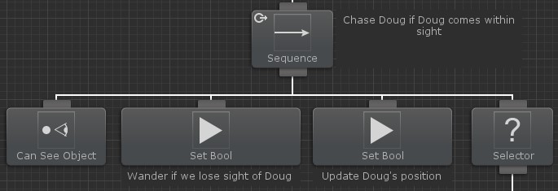

A Lower Priority Conditional Abort is used to allow the Can See Object task to be reevaluated every tick. When the agent can see the player the Wander Shared Variable will be set to true to allow the agent to start wandering if the agent loses sight of the player. This branch will be described later on. Similarly, the Update Position bool is enabled to allow the position to be updated within the Update Position branch. This branch has already been described and is parented to the main Parallel task. A Selector task is then used to start executing the tasks within the Attack branch:

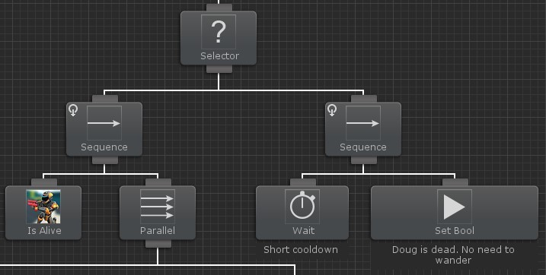

The player can only be attacked if they are alive. The first task that is executed is the Is Alive task to check the health of the player. A Self Conditional Abort is used to allow this task to be reevaluated every tick. If the player is alive a Parallel task is then run to allow the agent to do the actual attacking. If the player dies the Is Alive task will return failure and the Parallel branch will stop running. As soon as this happens the right branch will run which will prevent the agent from needing to wander. A task that prevents the agent from updating the position is not needed because that is set in a different branch.

There are two branches under the Parallel task. The left branch will do the actual firing of the agent's weapon:

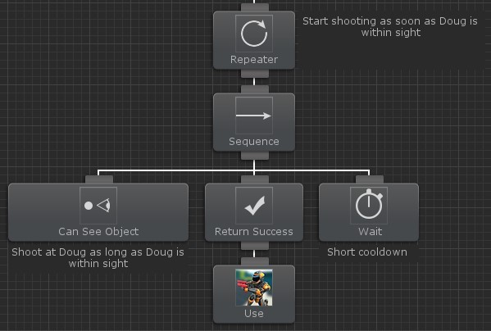

The agent will Use the weapon when the Can See Object task returns success. The Return Success task is used because the Use task may return failure and the following Wait task should always be executed. This prevents the agent from trying to fire his weapon every time the tree is ticked. No Conditional Aborts are needed because of the top Repeater task. This Repeater task is used to continue to execute this branch for as long as the other reevaluating conditional tasks allow it to run.

The right branch controls the actual movement of the agent. This branch ensures the agent is near and is looking at the player so the agent will successfully hit the player when he fires (click to enlarge).

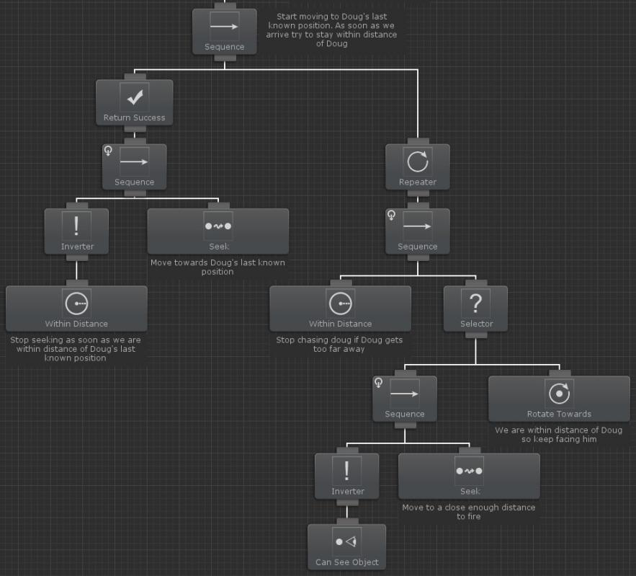

Unlike previous similar branches, this branch is parented by a Sequence task instead of a Selector branch. When the agent first sees the player he should Seek the player's Last Position until he is Within Distance. When the agent is within distance he should then only Seek the player's Last Position when the player is out of sight. The following branch will do the initial Seek to get the agent within firing distance of the player:

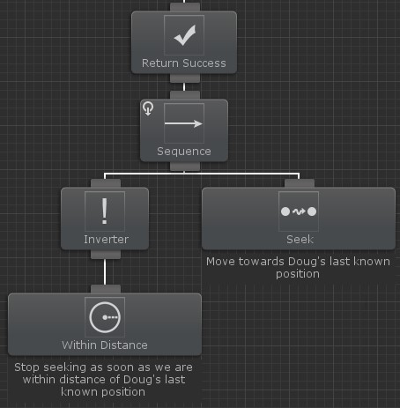

A Self Conditional Abort is used to stop the Seek task from running when the Within Distance task returns success. When the agent initially has to move towards the player, he may not be close enough to the player so the Within Distance task is going to return failure. The Inverter task is then used so the Seek task will only run when the Within Distance task returns failure, or the agent is not close to the player. Remember that we are not actually Seeking the player, instead we are seeking the position of the Last Position variable which is being updated in a higher level branch.

Once the agent is within distance of the player he will need to keep the player in sight so when he fires he will successfully hit the player:

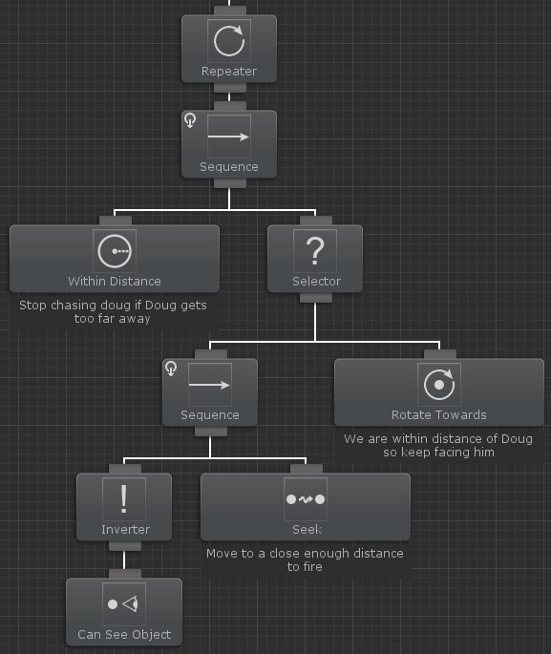

The Within Distance task is used again to stop the agent from seeking the player's Last Position. This task uses a larger distance than the previously described Within Distance task and the Can See Object task within this screenshot. This allows a small buffer zone where the agent will continue to seek the player and stop seeking if the distance becomes too far. For example, this Within Distance task can check to see if the player is within a distance of 20 units. The Can See Object task can then have a value of 10 so the agent will seek the player any distance between 10 and 20 units.

For as long as the Within Distance task returns true the right Can See Object branch will run. This is done using a Self Conditional Abort on the top Sequence task. A Selector task is then used to have the agent Seek the player's Last Position if the player is not within sight or distance. If the player is within sight and distance the Rotate Towards task keeps the agent facing the player.

This Attack branch provides the most visible agent functionality and while it branch looks complicated it can be broken down and explained really easily. The remaining branches have significantly less tasks than this attack branch. The next highest priority branch is a branch that will react to the agent taking damage from being shot at:

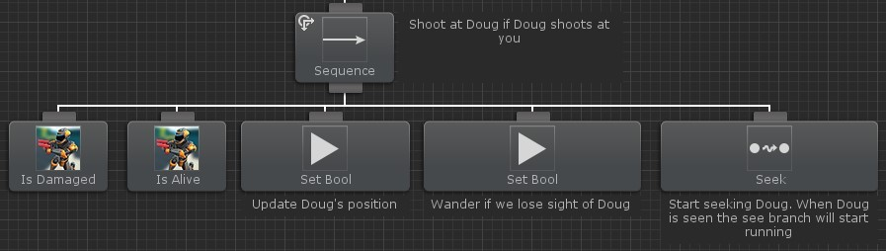

The Is Damaged task will return success when the agent takes damage. In this example scene the agent will take damage when the player shoots at the agent. A Both Conditional Abort is used to allow the Is Damaged task to stop the lower priority tasks from running if the agent takes damage. If the agent does take damage the Is Alive task will then check to see if the player is alive. In most cases this task won't be necessary but the player may have shot a projectile at the agent and died shortly after from something else, such as a different agent killing the player. Following the Is Alive check, the Update Position and Wander Shared Variables are set to true. This is similar to the variables being set to true within the higher priority See branch. After these variables are set to true the agent will then start to Seek the player's Last Position. No more tasks are needed for this branch because eventually the agent will see the player and the See branch will take over with its Lower Priority Conditional Abort.

In addition to reacting if the agent takes damage, the agent should also react if the agent hears a sound coming from the player. This could include footsteps or a weapon firing:

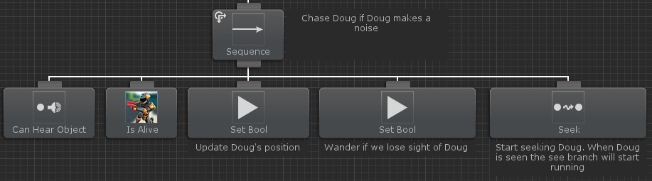

This branch is setup very similarly to the Damaged branch. The only difference being the first conditional task is Can Hear Object instead of Is Damaged. Can Hear Object will return success as soon as it hears a sound coming from the player within a specified distance. When this task returns success the Is Alive task will then run. In this case the Is Alive task is more useful than within the Damaged branch because the agent may hear the player dying and should not start to Seek the player if the player is dead. The Update Position and Wander variables are then set to true and the Seek task takes over. When the agent can see the player the See branch will stop the Seek task from running.

If the agent recently saw the player but the player is no longer within distance/sight of the agent then the agent will start to search for the player. The Wander Shared Variable is used by this branch (click to enlarge):

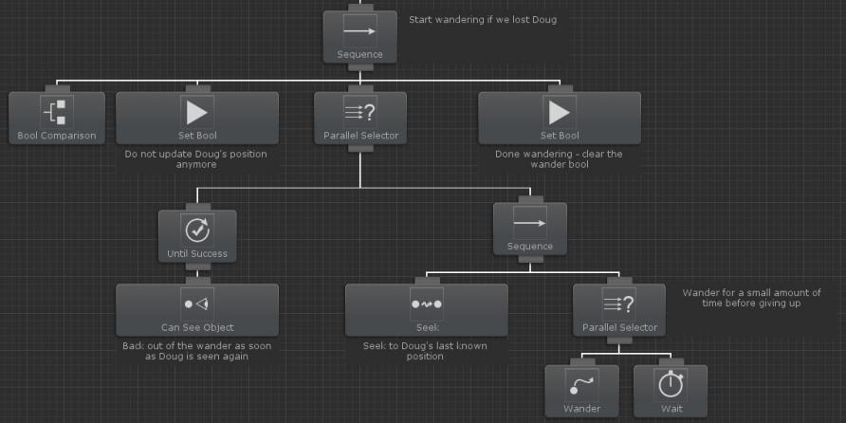

The Bool Comparison task is used to check to see if the Wander Shared Variable is set to true. Notice that unlike the previous branches, this branch does not have a Conditional Abort set because it is not needed. Wander is never going to be set to true by a lower priority branch so there is not a case where this branch can ever interrupt a lower priority branch. The first task that runs after Bool Comparison returns success is a task that sets the Update Position Shared Variable to false. This will prevent the Last Position from updating to the player's position so the agent cannot cheat to know where the player is.

The Parallel Selector task is then used to run both child branches at the same time. The Selector version of the Parallel task is used to stop the branch from running if one of the child branches returns success. It may look incorrect that another Can See Object task is used. After all, the See branch has a Lower Priority Conditional Abort set so it should interrupt this Wander branch if the player comes within sight. This is true but it hides an important detail of Conditional Aborts: Conditional Aborts are triggered when task execution status changes, not only when the conditional task returns success. Because of the way the Attack branch is setup it is possible for the agent to continue to see the player but not be within the Attack branch because the player is no longer within distance. In this case the Can See Object task is going to continue to return success while the Wander task is running. The Can See Object task within the Wander branch prevents the agent from wandering when the player can be seen. The Until Success task will return a status of running until the child task returns success. This allows the Parallel Selector task to keep running its children.

The right branch of the top Parallel Selector contains a Sequence task that will first Seek to the Last Position of the player. As soon as the agent arrives at that position another Parallel Selector task is used to run both the Wander task and Wait task. The Wander task always returns a status of running so the Wait task will stop the agent from wandering after a specified amount of time. As soon as the agent gets done wandering or can see the player the Set Bool task is run which will set Wander to false. Another higher priority branch can set the Wander value to true again.

The final branch within this tree is a small branch that will patrol the area if there is nothing else to do:

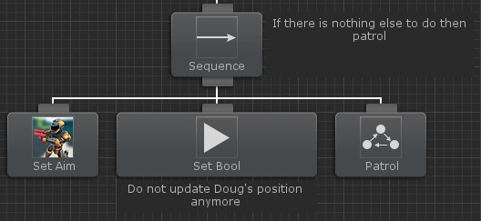

This branch does not have any conditional tasks because it is the lowest priority branch and should run if there are no higher priority branches to run. The first task will stop the agent from aiming, and the second task will set the Update Position Shared Variable to false to prevent the player's Last Position from updating. These tasks may not always be necessary depending on the previous branch that was run. The final task will Patrol a set of waypoints and will always return a status of running.

This tree was put together to give a complete example on how to design a behavior tree. Since behavior trees are so flexible there are many ways to accomplish this same behavior.

# UFPS

Ultimate FPS is a FPS asset which allows you to get a first person shooter up and running quickly. It has many features which manages the camera, weapons, inventory, and a lot more. Behavior Designer includes tasks which allow you to add the UFPS controls on an AI agent. Because UFPS is not specifically designed to be placed on an AI agent there is some extra setup required. UFPS integration files are located on the samples page because Behavior Designer doesn't require UFPS to work.

To get started, first make sure you have UFPS installed. Next, import UltimateFPSAssets.unitypackage:

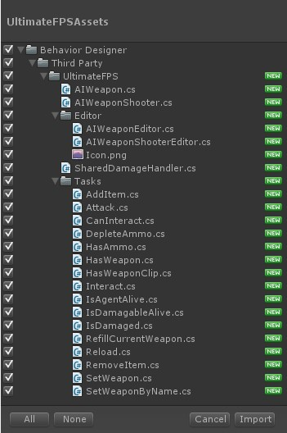

In this example our AI agent will be the soldier found in the Unity Bootcamp sample project. Add the following components to your agent: vp_WeaponHandler

vp_PlayerInventory vp_PlayerEventHandler

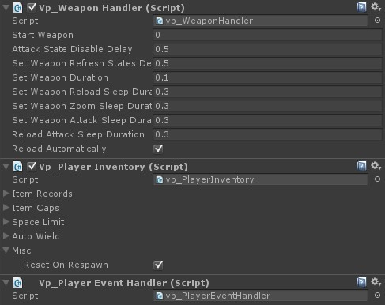

It is now time to add a weapon. Add the weapon to the solder's hand GameObject within the hierarchy window. In our case the M4 assault rifle has already been added to the solder. Take a look at the position handle within the scene.

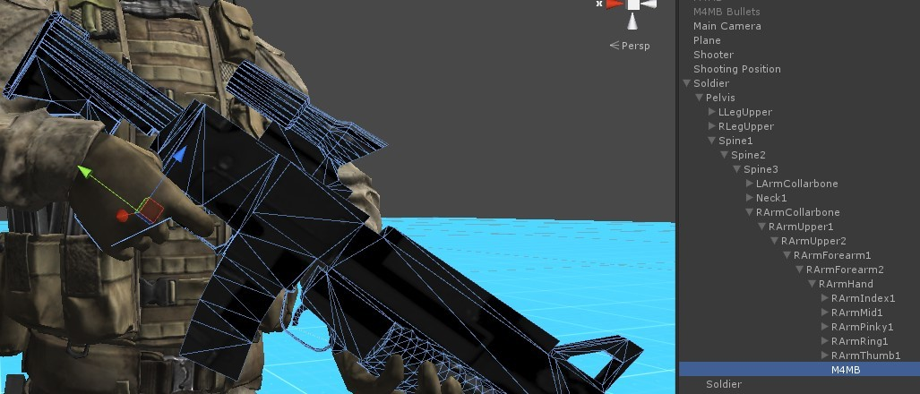

If the blue arrow (the forward vector) is facing in the same direction as the weapon then you do not have to perform the next step. When the UFPS tasks goes to aim the weapon they need to know which direction is forward. If the weapon's forward direction is not it's 'actual' forward direction then we need to add a parent GameObject which corrects this:

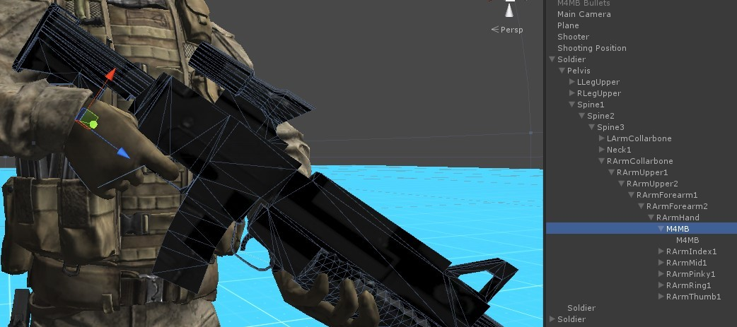

A parent GameObject (also called M4MB) has been added and now you can see that the blue arrow is facing in the same direction as the weapon. Once this is complete we can start adding the weapon components. The following components need to be added to the weapon's parent GameObject (or the original GameObject if no parent is needed):

AIWeapon AIWeaponShooter vp_WeaponReloader vp_ItemIdentifier

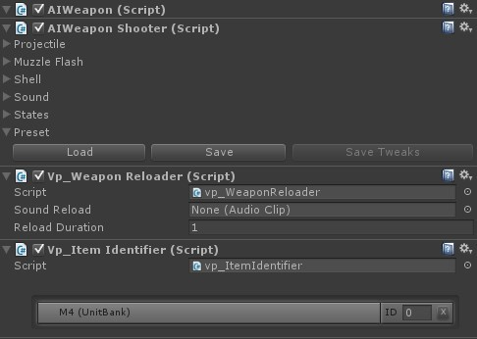

The last two components are standard UFPS and should already be familiar to you. The AIWeapon component is derived from vp_Weapon and it is basically there to prevent the vp_Weapon component from updating the position/rotation of the weapon. Since the AI is not in first person view we do not want UFPS managing the position of the weapon. This should be done with animations instead. AIWeaponShooter is derived from vp_Shooter and it is the script that actually shoots the weapon.

This is the only extra setup required. The rest of the steps (such as setting up the inventory) are similar to a standard UFPS setup which you can refer to from the UFPS manual.

In the UFPS sample scene we created the following behavior tree:

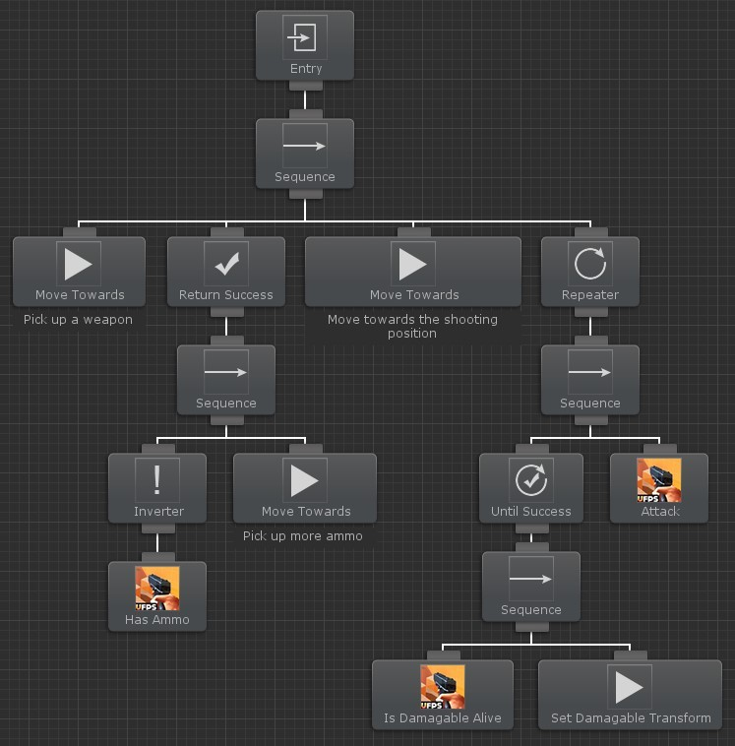

This behavior tree will have the soldier shoot at a target, reload, and pickup more bullets when necessary.

# uScript

uScript is a popular visual scripting tool which allows you to create complicated setups without needing to write a single line of code. Behavior Designer integrates directly with uScript by allowing uScript to carry out the action or conditional tasks and then resume the behavior tree from where it left off. uScript integration files are located on the samples page because uScript is not required for Behavior Designer to work.

To get started, first make sure you have uScript installed. Next, import uScriptAssets.unitypackage:

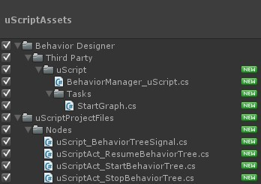

Once those files are imported you are ready to start creating behavior trees with uScript! To get started, create a very basic tree with a sequence task who has two Start Graph child tasks:

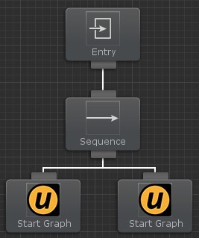

Now we need to create two GameObjects which will hold the compiled uScript graph:

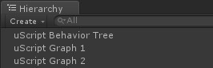

Open uScript and start creating a new graph. Add the Behavior Tree Signal node, located under Events/Signals. When Behavior Designer wants to start executing a uScript graph it will start from this node. This node contains four events – Start Signal, Pause Signal, Resume Signal, and End Signal. Start Signal is used when the behavior tree task starts running. Pause Signal gets called when the behavior tree is paused, and the Resume Signal gets called when the behavior tree resumes from being paused.

Finally, End Signal gets called when the uScript task ends. For our graph we are only going to create a few nodes, the uScript sample project shows a more complicated uScript graph. Create a node which has a delay of 3 seconds, sets a bool, then resumes the behavior tree. The Resume Behavior Tree node is located under Actions/Behavior Designer:

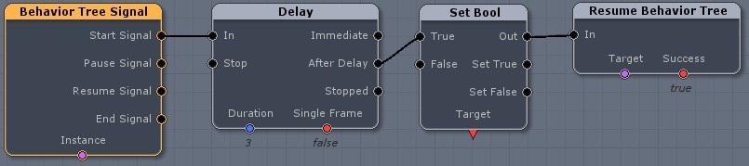

Now we need to create a Owner GameObject and bool variable.

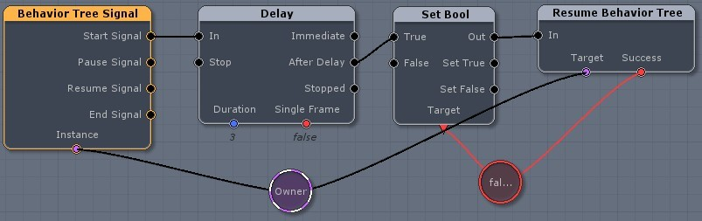

Save the uScript graph and assign the component to your first uScript graph GameObject. Answer no if uScript asks if you want to assign the component to the master GameObject.

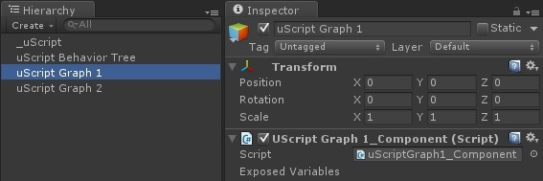

Create one more uScript graph. Make it the same as the last graph except set the bool to false:

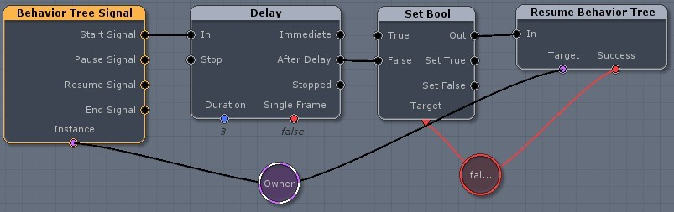

Finally save that graph and assign the component to the second uScript GameObject:

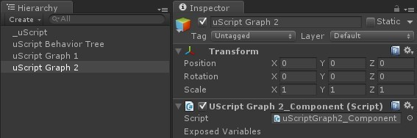

We’re almost done. The only thing left to do is to assign the correct uScript GameObject to the tasks within Behavior Designer. Open your behavior tree within Behavior Designer again. Click on the left uScript task and assign the uScript GameObject to your first uScript graph GameObject.

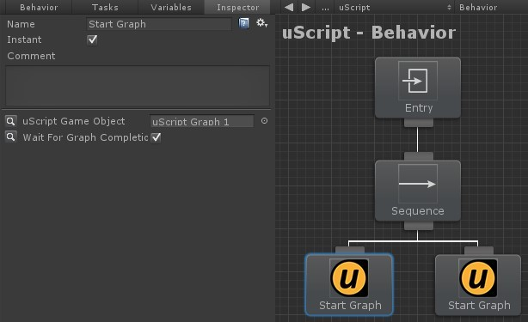

Do the same for the right uScript task, only assign the uScript GameObject to your second uScript graph GameObject. That's it! When you hit play you’ll see the first uScript task run for three seconds, followed by the second uScript task.

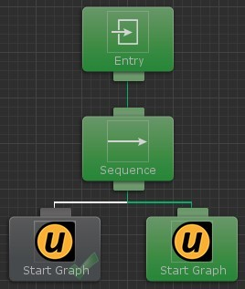

If you were to swap the tasks so the second uScript graph runs before the first uScript graph, the behavior tree will never get to the first uScript graph because the second uScript graph returned failure and the sequence task stopped executing its children.

# Task List

A collection of tasks form a behavior tree. Behavior Designer includes the tasks listed below with its default installation. For more tasks take a look at the sample projects or the Movement Pack.

Actions

Behavior Tree Reference Idle

Log

Perform Interruption Restart Behavior Tree Send Event

Start Behavior Stop Behavior Wait

Invoke Method Get Field Value Get Property Value Set Field Value Set Property Value

Composites

Sequence Selector Parallel

Parallel Selector Priority Selector Random Selector Random Sequence Selector Evaluator Utility Selector

Conditionals

Random Probability Compare Field Value Compare Property Value Has Received Event Physics

Decorators

Conditional Evaluator Interrupt

Inverter Repeater Return Failure Return Success Task Guard Until Failure Until Success

Basic Tasks

Animation Animator AudioSource Behaviour BoxCollider BoxCollider2D CapsuleCollider CharacterController CircleCollider2D Debug

GameObject Input LayerMask Light

Math Network

Particle System Physics Physics2D Player Prefs Quaternion Renderer Rigidbody Rigidbody2D String SharedVariable SphereCollider Transform Vector2 Vector3

Third Party

2D Toolkit Adventure Creator ICode

Anti-Cheat Toolkit Blox

Camera Path Animator Chronos

Cinema Director Control Freak Core GameKit Curvy

Dialogue System DOTween

Final IK Glow Effect Inventory Pro LeanTween Love/Hate Master Audio

Motion Controller NGUI

Particle Playground PlayMaker

Pool Boss Pool Manager

Realistic FPS Prefab SECTR

Simple Waypoint System Third Person Controller Trigger Event Pro uFrame

Ultimate FPS Uni2D UniStorm uScript uSequencer Vectrosity

Entry Task

# Actions

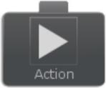

Action tasks alter the state of the game. For example, an action task might consist of playing an animation or shooting a weapon. Behavior Designer includes the following actions with its default installation. For more action examples take a look at sample projects.

Behavior Tree Reference

Idle Log

Perform Interruption Restart Behavior Tree Send Event

Start Behavior Stop Behavior Wait

Invoke Method Get Field Value Get Property Value Set Field Value Set Property Value

# Behavior Tree Reference

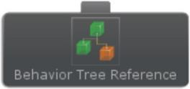

The Behavior Tree Reference task allows you to run another behavior tree within the current behavior tree. You can create this behavior tree by saving the tree as an external behavior tree. One use for this is that if you have an unit that plays a series of tasks to attack. You may want the unit to attack at different points within the behavior tree, and you want that attack to always be the same. Instead of copying and pasting the same tasks over and over you can just use an external behavior and then the tasks are always guaranteed to be the same. This example is demonstrated in the RTS sample project located on the samples page.

The GetExternalBehaviors method allows you to override it so you can provide an external behavior tree array that is determined at runtime.

The Behavior Tree Reference task allows you to specify variables per-reference task. For most cases this is not needed because variables will automatically be transferring from the parent tree to the External Tree. However, if you have multiple Behavior Tree Reference tasks in the same tree all pointing to the same External Tree, you may want to be able to specify different variable values per tree. In this situation you can specify the variable value on the Behavior Tree Reference task and that variable value will be transferred to the External Tree.

# Idle

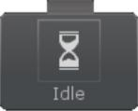

Returns a TaskStatus of running. Will only stop when interrupted or a conditional abort is triggered.

# Log

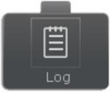

Log is a simple task which will output the specified text and return success. It can be used for debugging.

*text*

Text to output to the log.

*logError*

Is this text an error?

# Perform Interruption



Perform the actual interruption. This will immediately stop the specified tasks from running and will return success or failure depending on the value of interrupt success.

*interruptTasks*

The list of tasks to interrupt. Can be any number of tasks.

*interruptSuccess*

When we interrupt the task should we return a task status of success?

# Restart Behavior Tree

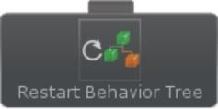

Restarts a behavior tree, returns success after it has been restarted.

*behavior*

The behavior tree that we want to start. If null use the current behavior

# Send Event



Sends an event to the behavior tree, returns success after sending the event.

*targetGameObject*

The GameObject of the behavior tree that should have the event sent to it. If null use the current behavior

*eventName*

The event to send

# Start Behavior

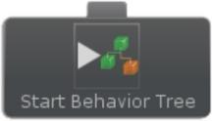

Start a new behavior tree and return success after it has been started.

*behavior*

The behavior that we want to start. If null use the current behavior.

# Stop Behavior

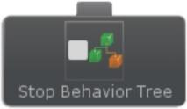

Pause or disable a behavior tree and return success after it has been stopped.

*behavior*

The behavior that we want to stop. If null use the current behavior.

*pauseBehavior*

Should the behavior be paused or completely disabled.

# Wait

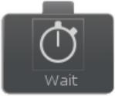

Wait a specified amount of time. The task will return running until the task is done waiting. It will return success after the wait time has elapsed.

*waitTime*

The amount of time to wait.

# Invoke Method

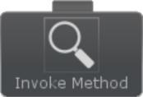

Invokes the specified method with the specified parameters. Can optionally store the return value. Returns success if the method was invoked.

*targetGameObject*

The GameObject to invoke the method on

*componentName*

The component to invoke the method on

*methodName*

The name of the method

*parameter1*

The first parameter of the method

*parameter2*

The second parameter of the method

*parameter3*

The third parameter of the method

*parameter4*

The fourth parameter of the method

*storeResult*

Store the result of the invoke call

# Get Field Value



Gets the value from the field specified. Returns success if the field was retrieved.

*targetGameObject*

The GameObject to get the field on

*componentName*

The component to get the field on

*fieldName*

The name of the field

*fieldValue*

The value of the field

# Get Property Value



Gets the value from the property specified. Returns success if the property was retrieved.

*targetGameObject*

The GameObject to get the property of

*componentName*

The component to get the property of

*propertyName*

The name of the property

*propertyValue*

The value of the property

# Set Field Value



Sets the field to the value specified. Returns success if the field was set.

*targetGameObject*

The GameObject to setthe field on

*componentName*

The component to set the field on

*fieldName*

The name of the field

*fieldValue*

The value to set

# Set Property Value



Sets the property to the value specified. Returns success if the property was set.

*targetGameObject*

The GameObject to setthe property of

*componentName*

The component to set the property of

*propertyName*

The name of the property

*propertyValue*

The value to set

# Composites



Composite tasks are parent tasks that hold a list of child tasks. For example, one composite task may loop through the child tasks sequentially while another task may run all of its child tasks at once. The return status of the composite tasks depends on its children.

Behavior Designer includes the following composites with its default installation. For more composite examples take a look at sample projects. Every composite task holds the property which specifies if conditional aborts should be used.

Sequence Selector Parallel

Parallel Selector Priority Selector Random Selector Random Sequence Selector Evaluator Utility Selector

# Sequence

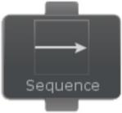

The sequence task is similar to an "and" operation. It will return failure as soon as one of its child tasks return failure. If a child task returns success then it will sequentially

run the next task. If all child tasks return success then it will return success.

# Selector

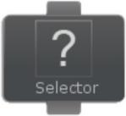

The selector task is similar to an "or" operation. It will return success as soon as one of its child tasks return success. If a child task returns failure then it will sequentially run the next task. If no child task returns success then it will return failure.

# Parallel

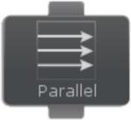

Similar to the sequence task, the parallel task will run each child task until a child task returns failure. The difference is that the parallel task will run all of its children tasks simultaneously versus running each task one at a time. Like the sequence class, the parallel task will return success once all of its children tasks have return success. If one tasks returns failure the parallel task will end all of the child tasks and return failure.

# Parallel Selector

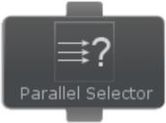

Similar to the selector task, the parallel selector task will return success as soon as a child task returns success. The difference is that the parallel task will run all of its children tasks simultaneously versus running each task one at a time. If one tasks returns success the parallel selector task will end all of the child tasks and return success. If every child task returns failure then the parallel selector task will return failure.

# Priority Selector

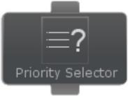

Similar to the selector task, the priority selector task will return success as soon as a child task returns success. Instead of running the tasks sequentially from left to right within the tree, the priority selector will ask the task what its priority is to determine the order. The higher priority tasks have a higher chance at being run first.

# Random Selector

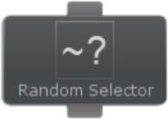

Similar to the selector task, the random selector task will return success as soon as a child task returns success. The difference is that the random selector class will run its children in a random order. The selector task is deterministic in that it will always run the tasks from left to right within the tree. The random selector task shuffles the child tasks up and then begins execution in a random order. Other than that the random selector class is the same as the selector class. It will continue running tasks until a task completes successfully. If no child tasks return success then it will return failure.

*seed*

Seed the random number generator to make things easier to debug.

*useSeed*

Do we want to use the seed?

# Random Sequence

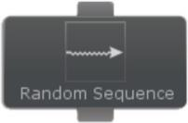

Similar to the sequence task, the random sequence task will return success as soon as every child task returns success. The difference is that the random sequence class will run its children in a random order. The sequence task is deterministic in that it will always run the tasks from left to right within the tree. The random sequence task shuffles the child tasks up and then begins execution in a random order. Other than that the random sequence class is the same as the sequence class. It will stop running tasks as soon as a single task ends in failure. On a task failure it will stop executing all of the child tasks and return failure. If no child returns failure then it will return success.

*seed*

Seed the random number generator to make things easier to debug.

*useSeed*

Do we want to use the seed?

# Selector Evaluator

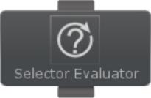

The selector evaluator is a selector task which reevaluates its children every tick. It will run the lowest priority child which returns a task status of running. This is done each tick. If a higher priority child is running and the next frame a lower priority child wants to run it will interrupt the higher priority child. The selector evaluator will return success as soon as the first child returns success otherwise it will keep trying higher priority children. This task mimics the conditional abort functionality except the child tasks don't always have to be conditional tasks

# Utility Selector



The Utility Selector task evaluates the child tasks using utility theory ai. The child task can override the at that particular time. The task with the highest utility value will be selected and the existing running task will be aborted. The Utility Selector task reevaluates its children every tick.

# Conditionals

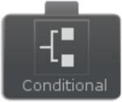

Conditional tasks test some property of the game. For example, a condition might be to check if an object is within sight or determine if the player is still alive. Behavior Designer includes the following conditionals with its default installation. For more conditional examples take a look at sample projects.

Random Probability

Compare Field Value Compare Property Value Has Received Event Physics

# Random Probability

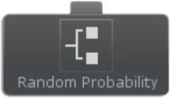

The random probability task will return success when the random probability is above the succeed probability. It will otherwise return failure.

*successProbability*

The chance that the task will return success.

*seed*

Seed the random number generator to make things easier to debug.

*useSeed*

Do we want to use the seed?

# Compare Field Value



Compares the field value to the value specified. Returns success if the values are the same.

*targetGameObject*

The GameObject to setthe field on

*componentName*

The component to set the field on

*fieldName*

The name of the field

*compareValue*

The value to compare to

# Compare Property Value



Compares the property value to the value specified. Returns success if the values are the same.

*targetGameObject*

The GameObject to setthe property of

*componentName*

The component to set the property of

*propertyName*

The name of the property

*compareValue*

The value to compare to

# Has Received Event

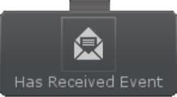

Returns success as soon as the event specified by eventName has been received.

*eventName*

The name of the event to receive

# Physics

The following tasks are included in the conditional physics category. These conditional tasks will only receive the physics callback if they are being reevaluated with a conditional abort.

Has Entered Collision Has Entered Collision2D Has Entered Trigger

Has Entered Trigger2D Has Exited Collision Has Exited Collision2D Has Exited Trigger

Has Exited Trigger2D

# Decorators

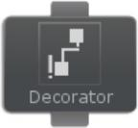

The decorator task is a wrapper task that can only have one child. The decorator task will modify the behavior of the child task in some way. For example, the decorator task may keep running the child task until it returns with a status of success or it may invert the return status of the child.

Behavior Designer includes the following decorators with its default installation. For more decorator examples take a look at sample projects.

Conditional Evaluator Interrupt

Inverter Repeater Return Failure Return Success Task Guard Until Failure Until Success

# Conditional Evaluator

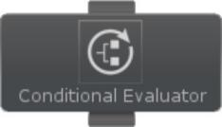

Evaluates the specified conditional task. If the conditional task returns success then the child task is run and the child status is returned. If the conditional task does not return success then the child task is not run and a failure status is immediately returned. The conditional task is only evaluated once at the start.

*reevaluate*

Should the conditional task be reevaluated every tick?

*conditionalTask*

The conditional task to evaluate

# Interrupt

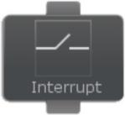

The interrupt task will stop all child tasks from running if it is interrupted. The interruption can be triggered by the perform interruption task. The interrupt task will keep running its child until this interruption is called. If no interruption happens and the child task completed its execution the interrupt task will return the value assigned by the child task.

# Inverter

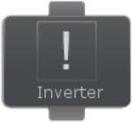

The inverter task will invert the return value of the child task after it has finished executing. If the child returns success, the inverter task will return failure. If the child returns failure, the inverter task will return success.

# Repeater

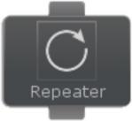

The repeater task will repeat execution of its child task until the child task has been run a specified number of times. It has the option of continuing to execute the child task even if the child task returns a failure.

*count*

The number of times to repeat the execution of its child task.

*repeatForever*

Allows the repeater to repeat forever.

*endOnFailure*

Should the task return if the child task returns a failure.

# Return Failure

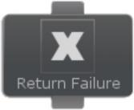

The return failure task will always return failure except when the child task is running.

# Return Success

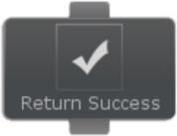

The return success task will always return success except when the child task is running.

# Task Guard

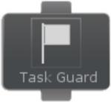

The task guard task is similar to a semaphore in multithreaded programming. The task guard task is there to ensure a limited resource is not being overused. For example, you may place a task guard above a task that plays an animation. Elsewhere within your behavior tree you may also have another task that plays a different animation but uses the same bones for that animation. Because of this you don't want that animation to play twice at the same time. Placing a task guard will let you specify how many times a particular task can be accessed at the same time. In the previous animation task example you would specify an access count of 1. With this setup the animation task can be only controlled by one task at a time. If the first task is playing the animation and a second task wants to control the animation as well, it will either have to wait or skip over the task completely.

*maxTaskAccessCount*

The number of times the child tasks can be accessed by parallel tasks at once. Marked as SynchronizeField to synchronize the value between any linked tasks.

*linkedTaskGuards*

The linked tasks that also guard a task. If the task guard is not linked against any other tasks it doesn't have much purpose. Marked as LinkedTask to ensure all tasks linked are linked to the same set of tasks.

*waitUntilTaskAvailable*

If true the task will wait until the child task is available. If false then any unavailable child tasks will be skipped over.

# Until Failure

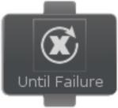

The until failure task will keep executing its child task until the child task returns failure.

# Until Success

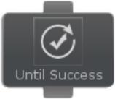

The until success task will keep executing its child task until the child task returns success.

# Basic Tasks

Behavior Designer includes a large number of tasks to accomplish basic operations, such as getting the velocity of a Rigidbody or playing a Mecanim state. The following categories of tasks are included:

Animation Animator AudioSource Behaviour BoxCollider

BoxCollider2D CapsuleCollider CharacterController CircleCollider2D Debug

GameObject Input LayerMask Light

Math Network

Particle System Physics Physics2D Player Prefs Quaternion Renderer Rigidbody Rigidbody2D String SharedVariable SphereCollider Transform Vector2 Vector3

# Animation

The following tasks are included in the Animation category: Blend

CrossFade

CrossFadeQueued GetAnimatePhysics IsPlaying

Play PlayQueued Rewind Sample

SetAnimatePhysics SetWrapMode Stop

# Animator

The following tasks are included in the Animator category: CrossFade

GetApplyRootMotion

GetBoolParameter GetDeltaPosition GetDeltaRotation GetFloatParameter GetGravityWeight GetIntegerParameter GetLayerWeight GetSpeed InterruptMatchTarget IsInTransition

IsParameterControlledByCurve MatchTarget

Play SetApplyRootMotion SetBoolParameter SetFloatParameter SetIntegerParameter SetLayerWeight SetLookAtPosition SetLookAtWeight SetSpeed

SetTrigger StartPlayback StartRecording StopPlayback

StopRecording

# AudioSource

The following tasks are included in the AudioSource category: GetIgnoreListenerPause

GetIgnoreListenerVolume

GetLoop GetMaxDistance GetMinDistance GetMute

GetPan GetPanLevel GetPitch GetSpeed GetPriority GetSpread GetTime GetTimeSamples GetVolume IsPlaying

Pause Play

PlayDelayed PlayOneShot PlayScheduled SetIgnoreListenerPause SetIgnoreListenerVolume SetLoop SetMaxDistance SetMinDistance

SetMute SetPan SetPanLevel SetPitch SetPriority

SetRolloffMode SetScheduledEndTime SetScheduledStartTime SetSpread

SetTime SetVelocityUpdateMode SetVolume

Stop

# Behaviour

The following tasks are included in the Behaviour category: GetIsEnabled

IsEnabled

SetIsEnabled

# BoxCollider

The following tasks are included in the BoxCollider category: GetCenter

GetSize

SetCenter SetSize

# BoxCollider2D

The following tasks are included in the BoxCollider2D category. These tasks first need to be extracted from the BasicTasks2D Unity Package. GetCenter

GetSize

SetCenter SetSize

# CapsuleCollider

The following tasks are included in the CapsuleCollider category: GetCenter

GetDirection

GetHeight GetRadius SetCenter SetDirection SetHeight SetRadius

# CharacterController

The following tasks are included in the CharacterController category: GetCenter

GetHeight

GetRadius GetSlopeLimit GetStepOffset GetVelocity IsGrounded Move SetCenter SetHeight SetRadius SetSlopeLimit SetStepOffset SimpleMove

# CircleCollider2D

The following tasks are included in the CircleCollider2D category. These tasks first need to be extracted from the BasicTasks2D Unity Package. GetCenter

GetRadius

SetCenter SetRadius

# Debug

The following tasks are included in the Debug category:

DrawLine DrawRay LogValue

# GameObject

The following tasks are included in the GameObject category: ActiveInHierarchy

ActiveSelf

CompareTag Destroy DestroyImmediate Find

FindWithTag GetComponent GetTag SendMessage SetActive SetTag

# Input

The following tasks are included in the Input category: GetAcceleration

GetAxis

GetAxisRaw GetButton GetKey IsButtonDown IsButtonUp IsKeyDown IsKeyUp

# LayerMask

The following tasks are included in the LayerMask category: GetLayer

SetLayer

# Light

The following tasks are included in the Light category: GetColor

GetCookieSize

GetIntensity GetRange GetShadowBias GetShadowSoftness

GetShadowSoftnessFade GetShadowStrength GetSpotAngle

SetColor SetCookieSize SetCullingMask SetIntensity SetRange SetShadowBias SetShadows SetShadowSoftness

SetShadowSoftnessFade SetShadowStrength SetSpotAngle

SetType

# Math

The following tasks are included in the Math category: BoolComparison

BoolOperator FloatComparison FloatOperator IntComparison IntOperator RandomBool RandomFloat RandomInt SetBool

SetFloat SetInt

# Network

The following tasks are included in the Network category: IsClient

IsServer

# Particle System

The following tasks are included in the Particle System category: Clear

GetDuration

GetEmissionRate

GetEnableEmission GetGravityModifier GetLoop GetMaxParticles GetParticleCount GetPlaybackSpeed GetTime

IsAlive IsPaused IsPlaying IsStopped Pause Play

SetEmissionRate SetEnableEmission SetGravityModifier SetLoop SetMaxParticles SetPlaybackSpeed SetStartColor SetStartDelay StartStartLifetime SetStartRotation SetStartSize SetStartSpeed SetTime

Simulate Stop

# Physics

The following tasks are included in the Physics category: Linecast

Raycast

Spherecast

# Physics2D

The following tasks are included in the Physics2D category: Circlecast

Linecast

Raycast

# Player Prefs

The following tasks are included in the Player Prefs category: DeleteAll

DeleteKey

GetFloat GetInt GetString HasKey Save SetFloat SetInt SetString

# Quaternion

The following tasks are included in the Quaternion category: Angle

AngleAxis

Dot Euler

FromToRotation Identity

Inverse Lerp

LookRotation RotateTowards Slerp

# Renderer

The following task is included in the Renderer category: IsVisible

# Rigidbody

The following task is included in the Rigidbodycategory: AddExplosionForce

AddForce

AddForceAtPosition AddRelativeForce AddRelativeTorque AddTorque GetAngularDrag GetAngularVelocity GetCenterOfMass GetDrag GetFreezeRotation GetIsKinematic GetMass GetPosition GetRotation GetUseGravity GetVelocity IsKinematic IsSleeping MovePosition MoveRotation SetAngularDrag SetAngularVelocity SetCenterOfMass SetConstraints SetDrag SetFreezeRotation SetIsKinematic SetMass

SetPosition

SetRotation SetUseGravity SetVelocity Sleep UseGravity WakeUp

# Rigidbody2D

The following tasks are included in the Rigidbody2D category. These tasks first need to be extracted from the BasicTasks2D Unity Package. AddForce

AddForceAtPosition

AddTorque GetAngularDrag GetAngularVelocity GetDrag GetFixedAngle GetGravityScale GetIsKinematic GetMass GetVelocity IsKinematic IsSleeping SetAngularDrag SetAngularVelocity SetDrag SetFixedAngle SetGravityScale

SetIsKinematic SetMass SetVelocity Sleep

WakeUp

# String

The following tasks are included in the String category: BuildString

Format

GetLength GetRandomString GetSubstring IsNullOrEMpty Replace

SetString

# SharedVariable

The following tasks are included in the SharedVariable category: CompareSharedBool

CompareSharedColor

CompareSharedFloat CompareSharedGameObject CompareSharedGameObjectList CompareSharedInt CompareSharedObject CompareSharedObjectList CompareSharedQuaternion CompareSharedRect CompareSharedString CompareSharedTransform CompareSharedTransformList CompareSharedVector2 CompareSharedVector3 CompareSharedVector4 SetSharedBool

SetSharedColor

SetSharedFloat SetSharedGameObject SetSharedGameObjectList SetSharedInt SetSharedObject SetSharedObjectList SetSharedQuaternion SetSharedRect SetSharedString SetSharedTransform SetSharedTransformList SetSharedVector2 SetSharedVector3 SetSharedVector4

SharedGameObjectToTransform SharedTransformToGameObject

# SphereCollider

The following tasks are included in the SphereCollider category: GetCenter

GetRadius

SetCenter SetRadius

# Transform

The following tasks are included in the Transform category: Find

FindChild GetChild GetChildCount GetEulerAngles

GetLocalEulerAngles GetLocalPosition GetLocalRotation GetLocalScale GetParent GetPosition GetRotation IsChildOf

LookAt Rotate RotateAround

SetEulerAngles SetLocalEulerAngles SetLocalRotation SetLocalScale SetParent SetPosition SetRotation Translate

# Vector2

The following tasks are included in the Vector2 cateogry: ClampMagnitude

Distance

Dot GetMagnitude GetRightVector GetSqrMagnitude GetUpVector GetVector3 GetXY

Lerp MoveTowards Multiply Normalize Operator SetValue SetXY

# Vector3

The following tasks are included in the Vector3 cateogry: ClampMagnitude

Distance

Dot GetForwardVector GetMagnitude GetRightVector GetSqrMagnitude GetUpVector GetVector2 GetXYZ

Lerp MoveTowards Multiply Normalize Operator RotateTowards SetValue SetXYZ

# Third Party

Behavior Designer contains tasks for the following third party assets:

2D Toolkit

Adventure Creator ICode

Anti-Cheat Toolkit Blox

Camera Path Animator Chronos

Cinema Director Control Freak Core GameKit Curvy

Dialogue System DOTween

Final IK Glow Effect Inventory Pro LeanTween Love/Hate Master Audio

Motion Controller NGUI

Particle Playground PlayMaker

Pool Boss Pool Manager

Realistic FPS Prefab SECTR

Simple Waypoint System Third Person Controller Trigger Event Pro uFrame

Ultimate FPS Uni2D UniStorm uScript uSequencer Vectrosity

# 2D Toolkit

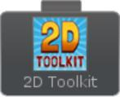

The following tasks are included in the 2D Toolkit integration: Get Sprite Color

Get Sprite ID

Get TextMesh Anchor Get TextMesh Colors Get TextMesh Font

Get TextMesh Inline Styling Get TextMesh Max Chars

Get TextMesh Num Drawn Characters Get TextMesh Properties

Get TextMesh Scale Get TextMesh Text

Get TextMesh Texture Gradient Is Playing

Is TextMesh Inline Styling Available Make Sprite Pixel Perfect

Make TextMesh Pixel Perfect Pause Animation

Play Animation Resume Animation

Set Animation Frame Rate Set Sprite Color

Set Sprite ID Set Sprite Scale

Set TextMesh Anchor Set TextMesh Colors Set TextMesh Font

Set TextMesh Inline Styling Set TextMesh Max Chars Set TextMesh Properties

Set TextMesh Scale Set TextMesh Text

Set TextMesh Texture Gradient Stop Animation

The following tasks are included in the Adventure Creator integration: Synchronize Bool

Synchronize Float Synchronize Int Synchronize String

# Adventure Creator

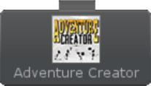

The following tasks are included in the ICode integration: Start State Machine

Stop State Machine Run State Machine

# ICode

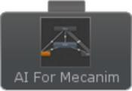

The following tasks are included with the Anti-Cheat Toolkit integration: Detectors/Injection Detected (doc)

Detectors/Obscured Cheating Detected (doc) Detectors/Speed Hack Detected (doc) Obscured Prefs/Altered

Obscured Prefs/Delete All Obscured Prefs/Delete Key Obscured Prefs/Get Bool Obscured Prefs/Get Color Obscured Prefs/Get Float Obscured Prefs/Get Int Obscured Prefs/Get Quaternion Obscured Prefs/Get String Obscured Prefs/Get Vector2 Obscured Prefs/Get Vector3 Obscured Prefs/Has Key Obscured Prefs/Save

Obscured Prefs/Set Bool Obscured Prefs/Set Color Obscured Prefs/Set Float Obscured Prefs/Set Int

Obscured Prefs/Set New Crypto Key Obscured Prefs/Set Quaternion Obscured Prefs/Set String

Obscured Prefs/Set Vector2 Obscured Prefs/Set Vector3

# Anti-Cheat Toolkit



**Blox**



The following tasks are included with the Blox integration:

Run Event Start Blox

# Camera Path Animator



The following tasks are included with the Camera Path Animator integration: Get Path Speed

Pause Play Seek

Set Animation Mode Set Orientation Mode Set Path Speed/Stop

# Chronos



The following tasks are included with the Chronos integration:

Get Base Speed Get Clock Info Get Global Clock Get Timeline Info Pause Clock

Physics 2D/Add Force 2D Physics 2D/Add Torque 2D Physics 2D/Get Mass 2D Physics 2D/Get Speed 2D Physics 2D/Get Velocity 2D Physics 2D/Is Kinematic 2D Physics 2D/Set Is Kinematic 2D Physics 2D/Set Mass 2D Physics 2D/Set Velocity 2D

Physics 3D/Add Explosion Force Physics 3D/Add Force

Physics 3D/Add Torque Physics 3D/Get Mass Physics 3D/Get Speed Physics 3D/Get Velocity Physics 3D/Is Kinematic Physics 3D/Set Drag

Physics 3D/Set IS Kinematic Physics 3D/Set Mass Physics 3D/Set Velocity Physics 3D/Use Gravity Release Area Clock

Release Timeline Scale Clock Time

Scale Clock Time Smoothly Scale Global Clock Time

Scale Global Clock Time Smoothly Schedule

Set Base Speed Timeline State Switch

# Cinema Director

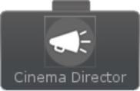

The following tasks are included with the Cinema Director integration:

Pause Play Skip Stop

The following tasks are included with the Control Freak integration: Get Axis

Get Axis Raw Get Axis Vector Get Button

Get Key

Is Button Down Is Button Up

Is Key Down Is Key Up

# Control Freak

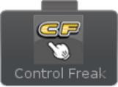

The following tasks are included in the Core GameKit integration: Add Float

Add Int

Attack Or Hit Points Add Attack Or Hit Points Mod Despawn

Despawn All Prefabs Despawn Killable Despawn Prefabs of Type Destroy

End Triggered Wave End Wave

Get Current Hit Points Get Float

Get Int Goto Wave

Is Tiggered Wave Spawning Kill All Prefabs

Kill Prefabs of Type Multiply Float Multiply Int

Pause Wave

Prefab Despawned Count Prefab Is In Pool

Prefab Spawned Count Prefab Total Count

Prefab Type Count In Pool Restart Wave

Resume Wave Set Float

Set Int

Spawn From Pool Spawn One

Take Damage

# Core GameKit



Temporary Invincibility

The following tasks are included with the Curvy integration: Align To Spline

Create Spline

Delete Control Points Follow Spline

Get Control Points Get Nearest Point Get Segment Value Get Value

Is Initialized

Move Along Spline

Set Clone Builder Source Set Control Points

# Curvy



The following tasks are included with Dialogue System integration: Bark

Get Quest Entry State Get Quest State

Is Lua True Run Lua

Set Quest Entry State Set Quest State

Start Sequence Stop Conversation Stop Sequence

# Dialogue System

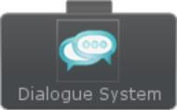

The following tasks are included with the DOTween integration: Color To

Local Move Local Move X Local Move Y Local Move Z Local Rotate Look At Move

Move X Move Y Move Z Rotate Scale Scale X Scale Y Scale Z Float To Init

Int To Kill

# DOTween

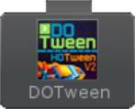

Pause Play Rect To

Set Delay Set Easy String To Toggle Pause Vector2 To Vector3 To Vector4 To

The following tasks are included in the Final IK integration: Aim IK

Biped IK CCD IK FABR IK

FABR IK Root FABR IK Root Chain FBB IK Body

FBB IK Limb FBB IK Settings

IK Execution Order Limb IK

Look At IK Pause Interaction

Resume Interaction Start Interaction Stop Interaction Trigonometric IK

# Final IK



The following tasks are included with the Glow Effect integration: Get Blur Iterations

Get Blur Spread

Get Glow Color Multiplier Get Glow Strength

Set Blur Iterations Set Blur Spread

Set Glow Color Multiplier Set Glow Strength

# Glow Effect



The following tasks are included with the Inventory Pro integration: Add Items From Treasure Chest

Add Item To Collection Add Item To Inventory

Crafting Enable Disable Blueprint Drop This Item

Generate Items

Open Close Treasure Chest Pickup This Item

# Inventory Pro

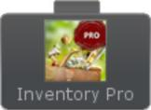

Sell Items To Vender Set Items Collection

Set Items Treasure Chest Set Items Vender

UI Show Hide UI Window UI Show Notice Message Use Item

Use This Item

The following tasks are included with the LeanTween integration: Alpha

Cancel Cancel All Color

Color Value Float Value Init

Int Value Move Move Local

Move Spline Move Spline Local Move X

Move Y Move Z Pause Pause All Resume Resume All Rotate

Rotate Around Rotate Around Local Rotate Local

Rotate X Rotate Y Rotate Z Scale Scale X Scale Y Scale Z Set Delay Set Ease

Vector2 Value Vector3 Value

# LeanTween



The following tasks are included with the Love/Hate integration: Add Direct Parent

Get Affinity Get Arousal Get Dominance

Get Faction Name Get Happiness Get Pleasure

Get Relationship Trait Get Temperament Has Ancestor

Has Direct Parent

# Love/Hate

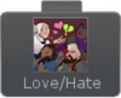

Knows Deed Modify Affinity Modify PAD

Modify Relationship Trait Remove Direct Parent Report Deed

Set Affinity

Set Relationship Trait Share Rumors

# Master Audio



The following tasks are included in the Master Audio integration: Add Ducking Group

Change Variation Pitch Fade Bus

Fade Group

Fade Out All Of Sound Group Fade Playlist

Fire Custom Event

Get Current Playlist Clip Name Mute Bus

Mute Everything Mute Group Mute Playlist Next Playlist Clip Pause Bus

Pause Everything Pause Group Pause Mixer Pause Playlist

Play Playlist By Clip Name Play Random Playlist Clip Play Sound

Remove Ducking Group Set Bus Volume

Set Group Volume Set Master Volume Set Playlist Volume Solo Bus

Solo Group

Start Playlist By Name Stop All Of Sound Stop Bus

Stop Everything Stop Mixer Stop Playlist

Stop Transform Sound Toggle Ducking Toggle Group Mute Toggle Group Solo Toggle Playlist Mute Unmute Bus

Unmute Everything Unmute Group Unmute Playlist Unpause Bus Unpause Everything Unpause Group Unpause Mixer Unpause Playlist Unsolo Bus

Unsolo Group

# Motion Controller

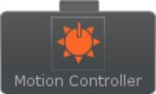

The following tasks are included with the Motion Controller integration:

Activate Motion Deactivate Motion

Set Active Motion Phase Is Motion Active Traverse Towards Traverse Patrol

The following tasks are included in the NGUI integration: Button Is Enabled

Get Label Text

Get Scroll Bar Value Get Slider Value

Get Widget Alpha Get Widget Color

Set Button Is Enabled Set Label Text

Set Scroll Bar Value Set Slider Value

Set Sprite

Set Widget Alpha Set Widget Color Set Widget Enabled Simulate Click Widget Enabled

# NGUI



The following tasks are included with the Particle Playground integration: Destroy

Emit

Get Particles

Is Particle Event Set Alpha

Set Color Set Lifetime Set Material

Set Particle Count Set Size

Translate

# Particle Playground



**PlayMaker**



PlayMaker integration details can be found on the PlayMaker Integration topic. The following tasks are included with the PlayMaker integration: Broadcast Event

Run Conditional FSM Send Event

Start FSM Stop FSM

Synchronize Bool Synchronize Color Synchronize Float Synchronize GameObject Synchronize Int Synchronize Object Synchronize Quaternion Synchronize Rect Synchronize String Synchronize Vector2 Synchronize Vector3

The following tasks are included with the Pool Boss integration: Despawn

Despawn All Prefabs Despawn Prefabs Of Type Is In Pool

Item Despawned Count Item Spawned Count Item Total Count Prefab Count

Spawn

# Pool Boss



The following tasks are included in the PoolManager integration: Check If Prefab Pool Exists

Create Pool Create Prefab Pool Despawn

Destroy All Pools Destroy Pool

Get Pool Group

Get Pool Instances Count Get Pools Count

Spawn

# Pool Manager

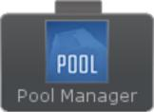

**Realistic FPS Prefab**

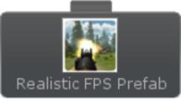

The following tasks are included with the Realistic FPS Prefab integration: Get Hit Points

Is Damaged Shoot

# SECTR



The follwoing tasks are included with the SCTR integration:

Audio/Start Stop Source Audio/Play Music Audio/Play Audio Cue Audio/Change Audio Bus Audio/Add Ambience Core/Open Door Core/Set Portal Flags Stream/Load Sector Vis/Enable Culling

# Simple Waypoint System

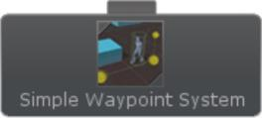

The following tasks are included in the Simple Waypoint System integration:

Chase Speed

Get Waypoint of Path Pause Movement Resume Movement Set Delay at Waypoint Set Path

Set Waypoint of Path Start Movement Stop Movement Update Bezier Path

# Third Person Controller

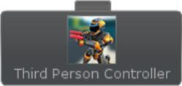

The Third Person Controller sample project contains a complete behavior tree which uses the Third Person Controller tasks. This tree is described in detail on this page. The following tasks are included with the Third Person Controller integration:

Action

Has Ammo

Has Current Item Is Alive

Is Damaged Move Reload

Set Aim Start Ability Stop Ability Switch Item Use

# Trigger Event Pro

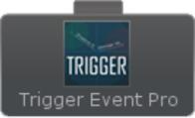

The following tasks are included with the Trigger Event Pro integration: Event Fire Controller/Has Event Trigger Spawned

Event Fire Controller/Has Firedd Event Fire Controller/Has Idle Updated Event Fire Controller/Has Pre Fired Event Fire Controller/Has Started Event Fire Controller/Has Stopped

Event Fire Controller/Has Target Updated Event Fire Controller/Has Updated

Event Trigger/Has Been Sorted

Event Trigger/Has Fired

Event Trigger/Has Fired Updated Event Trigger/Has Hit Target Event Trigger/Has Listen Started Event Trigger/Has Listen Updated

Event Trigger/Has New Target Been Detected Event Trigger/Has Targets Changed

Targetable/Is DetectedTargetable/Is HitTargetable/Is Not Detected

# uFrame



The following task is included with the uFrame integration. The Variable Synchronizer can also synchronize uFrame properties. Get it contact with us if you think any other uFrame tasks are appropriate.

Synchronize Property

# Ultimate FPS

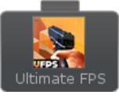

The following tasks are included with the UFPS integration:

Add Item Attack

Can Interact Deplete Ammo Has Ammo Has Weapon

Has Weapon Clip Interact

Is Agent Alive

Is Damagable Alive Is Damaged

Refill Current Weapon Reload

Remove Item Set Weapon

Set Weapon By Name

# Uni2D



The following tasks are included with the Uni2D integration: Animation/Get Frame Index

Animation/Get Frame Rate Animation/Get Normalized Time Animation/Get Speed Animation/Get Time Animation/Pause Animation/Play By Index Animation/Play By Name Animation/Play Current Animation/Resume Animation/Set Frame Index Animation/Set Frame Rate Animation/Set Normalized Time Animation/Set Speed Animation/Set Time Animation/Set Wrap Mode Animation/Stop

Sprite/Get Sorting Layer ID Sprite/Get Sorting Layer Name Sprite/Get Sorting Order Sprite/Get Vertex Color Sprite/Is Kinematic

Sprite/Is Trigger Sprite/Set Is Kinematic Sprite/Set Is Trigger

Sprite/Set Sorting Layer ID Sprite/Set Sorting Layer Name Sprite/Set Sorting Order Sprite/Set Vertex Color

# UniStorm



The following tasks are included with the UniStorm integration: Get Day Length

Get Days

Get Fog Density

Get Fog End Distance Get Fog Start Distance Get Hours

Get Max Sun Intensity Get Minutes

Get Months

Get Stormy Fog Distance Get Stormy Fog Start Get Sun Angle

Get Temperature

Get Weather Forcaster Get Years

Is Time Stopped Set Day Length Set Fog Density

Set Fog End Distance Set Fog Start Distance Set Max Sun Intensity Set Stormy Fog Distance Set Stormy Fog Start

Set Sun Angle Stop Time

# uScript



uScript integration details can be found in the uScript Integration topic. The following tasks are included with uScript integration: Start Graph

Run Conditional Graph

# uSequencer



The following tasks are included in the uSequencer integration: Is Sequence Playing

Pause Sequence

Play Sequence From Time Play Sequence

Set Sequence Time Stop Sequence

# Vectrosity



The following tasks are included with the Vectrosity integration: Destroy

Make Circle Make Cube Make Curve Make Ellipse Make Rect Make Spline Make Test Set Color Set Line

Set Line 3D Set Ray

Set Ray 3D Set Width

# Entry Task

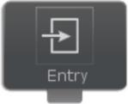

The entry task is a task that is used for display purposes within Behavior Designer to indicate the root of the tree. It is not a real task and cannot be used within the behavior tree.

# Support

We are here to help! If you have any questions/problems/suggestions please don't hesitate to ask. You can email us at [support@opsive.com](mailto:support@opsive.com) or post on the forum. For email support please include your Behavior Designer invoice number.